Distance Learning Committee (DLC)

Report to Academic Senate

November 12, 2020

SPOT
Action | Number of faculty
SPOT signups since March 3, 2020 | 467
SPOT signups July 1, 2018 – Feb. 23, 2020 | 198
SPOT completions since March 3, 2020 | 116
SPOT completions July 1, 2018 – Feb. 25, 2020 | 65
Total SPOT certified faculty as of Nov 10 | 384
Changes to SPOT
We have made many changes to SPOT to help our faculty improve their online pedagogy and ultimately benefit our students. These changes include:
- Added an abbreviated sample course as an example of good practice and what we’re looking for in SPOT (thank you, Mike Dowdle for putting this sample together based on his OEI aligned course)
- Addressed synchronous instruction best practices, including updating one of the SPOT quizzes to add questions based on this
- Used CidiLabs to make SPOT more attractive and accessible and to promote CidiLabs to faculty (thank you, Sandra Weatherilt for using her CidiLabs skills for this upgrade)
- Held weekly SPOT Zoom hours for faculty questions
- Held occasional synchronous SPOT Zoom training and added the recorded captioned videos to SPOT
- Updated references to the OEI rubric (which was updated in April 2020)
- Improved SPOT accessibility

SPOT Recertification
- 144 faculty have achieved recertification
- 18 faculty still have recertification due 12/31/20. If you do not want to be recertified, please let me know and I will remove you from the list!!
- 9 faculty still have recertification due 7/31/21
- Last approved SPOT recertification courses for the rest of the year scheduled for November 19 (go to POD Connect to register):
  - Next Design with Cidi Labs
  - 5 Tips to Make You an Accessibility Champ
  - Ally, Your Accessibility Partner in Canvas
- @ONE courses approved for SPOT recertification (register through @ONE, please note, these are moderated over four weeks and cost money):
  - Equity and Culturally Responsive Teaching in the Online Environment
  - Creating Accessible Course Content
  - Humanizing Online Teaching and Learning
- For updates on recertification, or to submit your evidence, please visit the SPOT Recertification webpage:
https://www.mtsac.edu/distancelearning/spotrecert.html

DL Amendment Forms
- Since July 2020, more than 350 courses have been reviewed and approved by DLC.
  - Faculty can either fill out the WebCMS OR the Smartsheet-linked form. Use WebCMS for FOMA courses. Use either method for “traditional” courses.

Please submit DL Amendment forms!!

Recommendations
The DLC submitted recommendations for Online Proctoring and for Camera Use During Online Synchronous Classes to C&I and were accepted and forwarded to Academic Senate Exec.

New DE (Distance Education) Regulations
New Distance Education Regulations were issued August 24, 2020. The regulations include more specific Regular and Effective Contact (Regular Substantive Interaction) expectations. These changes will be considered in updates to AP 4105 this year.

Faculty Facilitators
Faculty facilitators are still available to help you! Facilitators serve as online mentors for faculty this semester. Faculty can request online help via under “Additional Faculty Resources” on FCLT home page, under services on the Tools & Services for Faculty page, or via a Smartsheet link.
Request help via this form:
Request Help from a Faculty Facilitator

Distance Learning Report to the Board of Trustees
This report was prepared by: Dr. Meghan Chen, Dean, Library & Learning Resources and Carol Impara, Distance Learning Faculty Coordinator, for the meeting of the Board of Trustees, November 4, 2020.

Highlights of Accomplishments in Distance Learning 2019-20

Student Success Rates
- The Fall 2019 overall success rate in online classes was just 1% lower than the overall success rate in traditional face-to-face classes. In Fall 2018, the gap in overall success rates between online and face-to-face classes was 2%.
- The success rate in online classes in Fall 2019 compared to Fall 2018 showed a 14% increase among Latinx (from 47% to 61%) and a 7% decline among African American students (from 57% to 50%). The success rates among Asian-Americans and White/Caucasians showed no change at 82% and 72%, respectively.
- In Spring 2020, the College offered online, hybrid, and face-to-face (F2F) classes until March 31 when online classes stayed online; hybrid classes became fully online; and F2F classes became Temporary Remote Instruction (TRI). There were 6% of the traditional F2F classes that did not transition to online.
- The table below shows success rates in online classes in Fall 2019 overall and by racial groups, followed by Spring 2020 success rates by racial groups in online classes, hybrid classes that became fully online, and face-to-face classes that became online:

Student Success Rates | Fall 2019 Online | Spring 2020 Online, all semester | Spring 2020 Hybrid, then fully online | Spring 2020 Face-to-Face, then TRI
Overall | 62% | 71% | 69% | 63%
African Americans | 50% | 55% | 44% | 50%
Asian Americans | 82% | 86% | 83% | 79%
Latinx | 61% | 61% | 42% | 50%
Caucasian/White | 72% | 71% | 72% | 68%
Source: Argos report SHR0036. Success rates includes grades A, B, C, D, In Progress (IP).

Student Retention Rates

The overall retention rates in online classes in Fall 2019 was 85%. In Spring 2020, it was 78%.
When classes were held F2F in Fall 2019, the overall retention rate was 88%. In Spring 2020, in the face-to-face then TRI classes, it was 72%.

Academic Support Coordination

In 2019-20, the college's faculty, staff, and managers exemplified the Guided Pathways principles by collaborating strategically to reach out to students with our bevy of academic support resources. Our faculty, counselors, librarians, instructional specialists, and coaches shared resources with students even as the majority of our faculty pivoted quickly to teach online in the midst of Spring 2020. Student usage of some of our online support services increased from the previous year, which reflects multiple strategic efforts to promote these resources to students by faculty, counselors, librarians, staff and managers.

A Sample of Online Resources | 2018-19 | 2019-20
Online Counseling via Cranium Cafe* | 12 appointments (pilot phase) | 5,851 appointments  (and 1,683 email contacts)
24/7 Ask A Librarian real-time chat | 525 chats | 1,467 chats
Online Tutoring via NetTutor*  Mt. SAC's tutoring services online | 294 students  (small scale online tutoring) | 1,816 students  12,258 students (Spring 2020)
*Subsidized by the California Virtual Campus Online Education Initiative (CVC-OEI).

Faculty Professional Development

Faculty and Staff Worked Hard to Support High-Quality Online Instruction and Learning:
- A total of 170 new Distance Learning (DL) courses were approved in 2019-20. In 2018-19, 57 new DL courses were approved.
- The CCCCO identified summer 2020 and beyond as distance education and therefore required DL Amendment forms for all courses taught online.
  - Noncredit had never created DL Forms before. DL created a faculty workgroup to examine noncredit DL forms and have proposed a new form for correspondence courses.
  - A separate faculty workgroup reviews and recommends forms for approval, using the existing document method and the new method offered by WebCMS, which has been updated recently.
- In Spring 2020, hundreds of faculty completed training for Temporary Remote Instruction (TRI). Over 1,000 faculty members completed the four-hour Fully Online by Mutual Agreement Readiness (FOMAR) training in order to teach online courses in Summer and Fall 2020. TRI and FOMAR training were designed, built, and implemented by Faculty Center for Learning Technology (FCLT), DL faculty coordinators, and Professional and Organizational Development.
- Distance Learning faculty leaders were trained to guide faculty members through course alignment to the California Virtual Campus (CVC) Quality Rubric in order to meet our college's participation requirement in the CVC Course Exchange. These DL faculty leaders worked with 16 faculty members' courses. The local peer review team has been POCR (Peer Online Course Review) certified.***
- Seventeen faculty members adopted, adapted, or created open educational resources (free textbooks) for their classes, and more faculty are invited to participate in the next round in Summer/Fall 2020. This work saved 716 students a total of $104,835.***
- Twenty-one faculty members participated in @ONE’s Equity and Culturally Responsive Teaching course and infused equity-minded practices in their syllabuses.***
***Project funded by the Improving Online Career Technical Education Pathways grant

Technology-Supported Teaching, Learning, and Equity

The DL faculty coordinators, faculty mentors, and FCLT and Information Technology (IT), and POD teams supported high-quality Distance Learning instruction and learning with professional development activities and direct faculty support through various resources and multiple modalities.

The matrix below is a partial list of tools supported by FCLT. Resources in italics were created by FCLT.

Canvas* and upgrades | The Canvas Faculty Center
Labster* for lab courses | The Canvas Accessibility Center for faculty
Pronto for quick messaging to students | The Mountie Student Hub in Canvas (built by FCLT and Academic Support and Achievement Center)
Tools that support academic honesty:  - Proctorio* for exam proctoring  - Unicheck for plagiarism detection | Resources that promoted accessibility and equity:  - Cidi Labs DesignPLUS for course template design, identifying and automatically fixing inaccessible digital content  - Blackboard Ally* in Canvas for increasing accessible content  - Otter.ai transcription tool for Zoom  - Screencast-o-Matic for video accessibility  - NameCoach for recording pronunciation of names
*Subsidized by the California Virtual Campus Online Education Initiative (CVC-OEI).

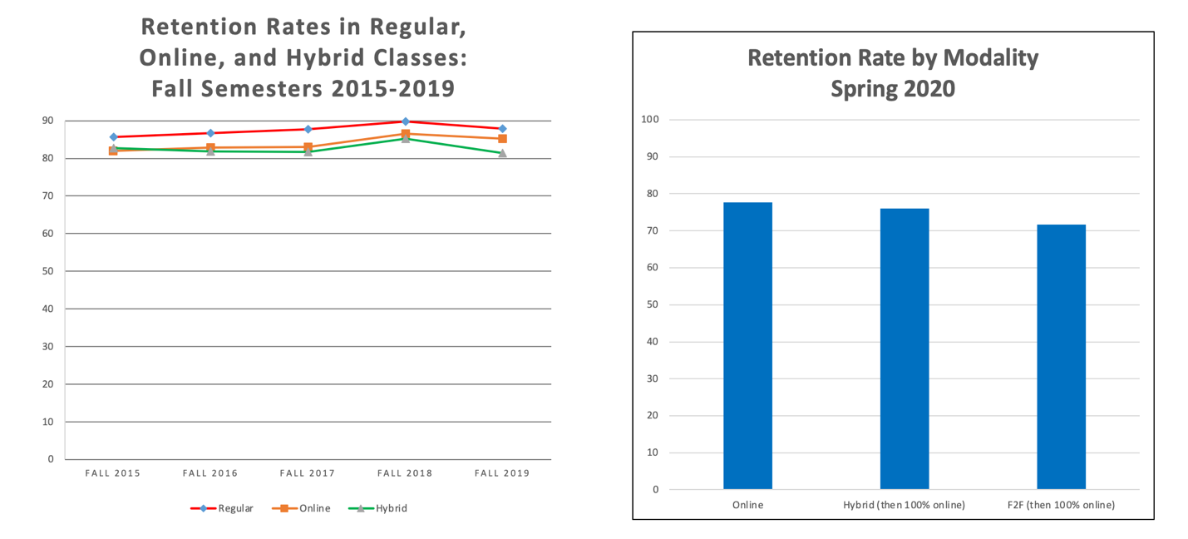
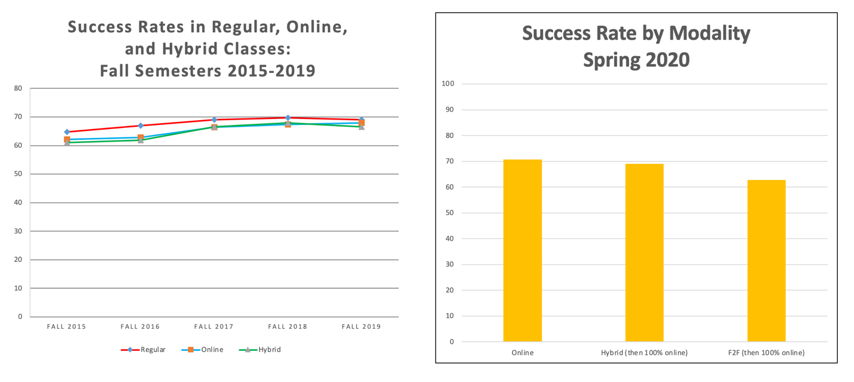

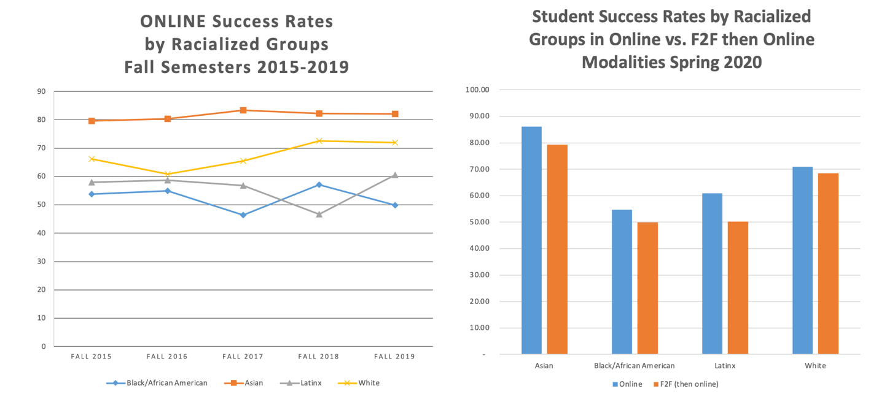

Respectfully submitted,
Carol Impara
Distance Learning Faculty Coordinator

