**Activating a student evaluation for your class**

10/29/2013

Instructors have the ability to activate an on-line student evaluation for their class. This is a pilot project for on-line evaluations beginning Fall 2013.

1. Access Faculty Self Service by clicking the 'Select Term' link from the Faculty Tab in the Portal:

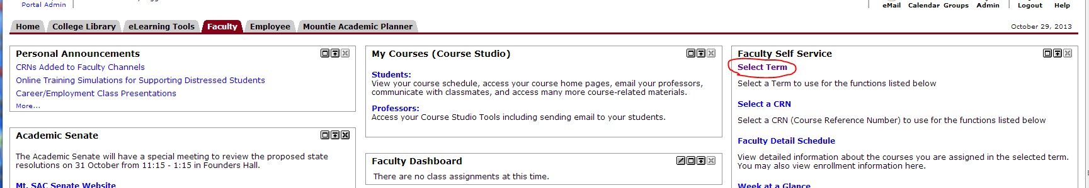

1. Select the current term, then click 'Submit'.

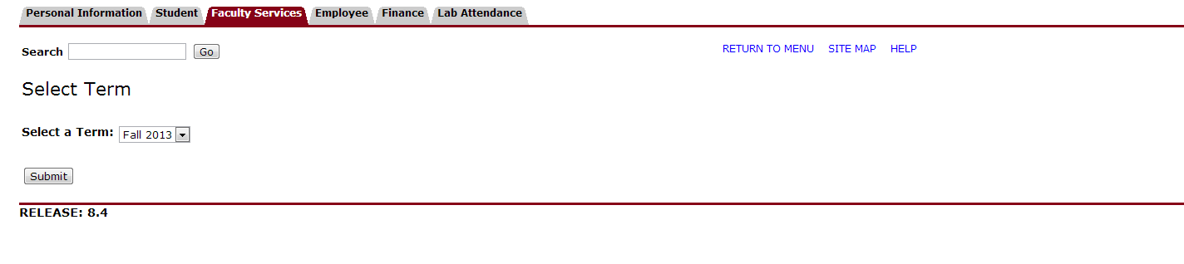

1. Click the menu item 'Activate a Student Evaluation of your Class'. This will be the last option in the menu.

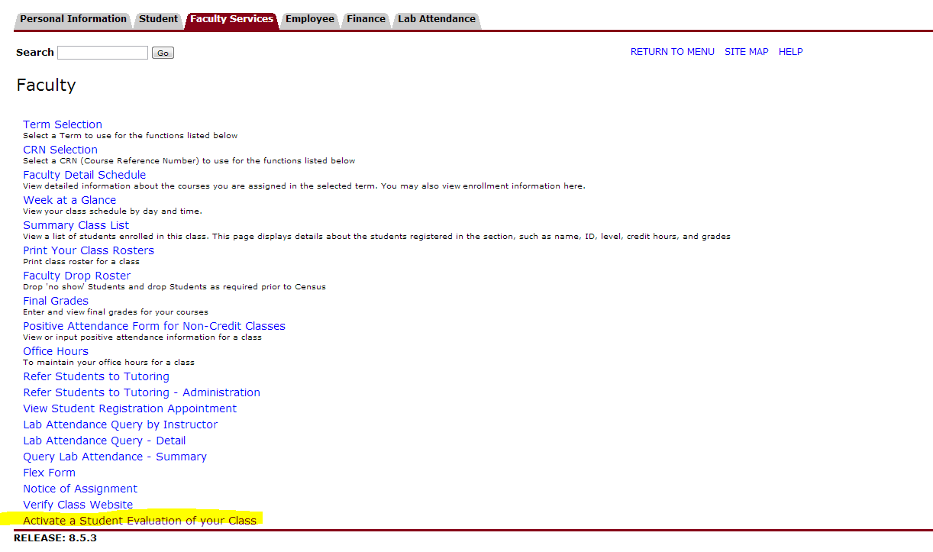

1. From the drop-down menu, select the proper survey code. **Note: There are two different evaluations – one for traditional classes, and another for on-line classes. Make sure you select the appropriate evaluation for your course. For traditional classes, choose 'Student Evaluation of Faculty 2011-14'.**

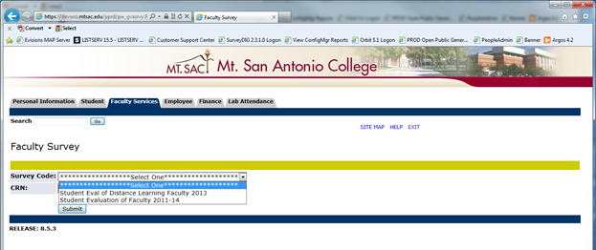

1. From the drop-down menu, select the CRN for which you would like to activate an evaluation. Only the courses for which you are the primary instructor will be listed.

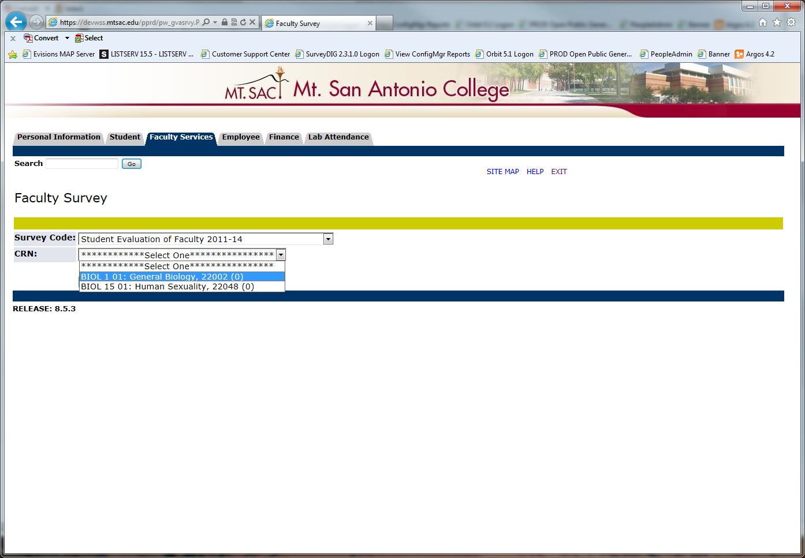

1. Verify the values in *Status Indicator* ('Active'), *From Date* and *To Date*. *From Date* will default to the current date; change this to a future date if you want to delay the start of the evaluation. *To Date* will default to a date 14 days from today; change this if you wish to change the end date of the evaluation period. Once the end date has passed, students are no longer able to access the evaluation.  
     
   The text in the *Info Text* field generally will not need to be changed. The "<br>" values are line breaks to format the description of the evaluation to provide clarity for the student.

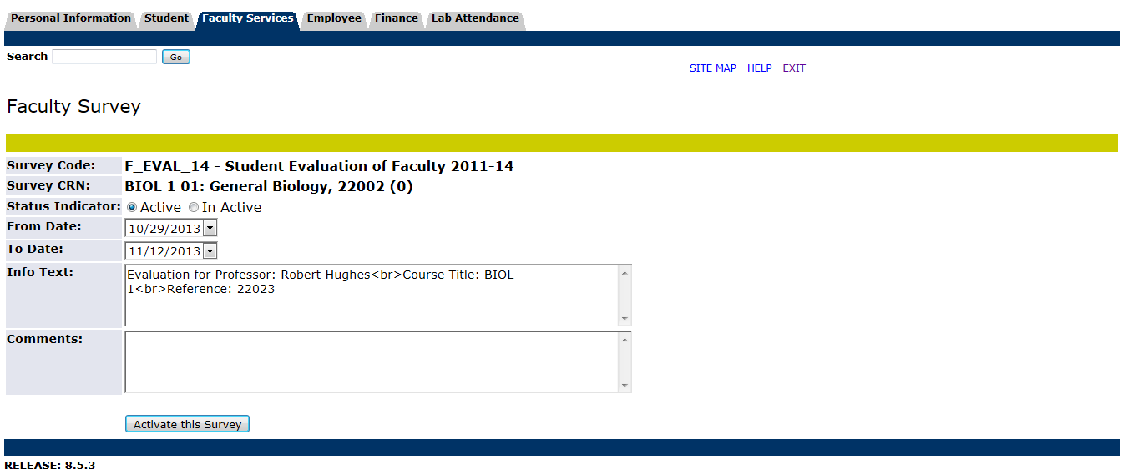

1. When you are satisfied with the settings for your student evaluation, click 'Activate this Survey'. You should see the following confirmation:

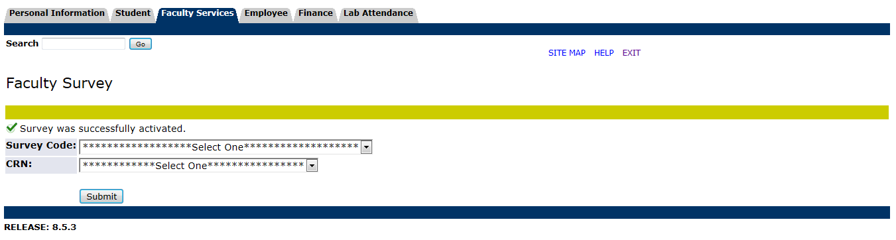

1. Repeat steps 4 – 7 to activate additional evaluations for your classes. If you need to change the settings for your evaluation, repeat steps 4 – 7. Evaluations that have previously been created will be presented so you can update them.
2. Students will automatically have an e-mail sent to them with a link to complete the evaluation the day following the *From Date* of the evaluation. Students who have not completed the evaluation will receive e-mail reminders every other day up to the *To Date.* Emails to students will contain a link to the url <http://www.tinyurl.com/mtsac-evals>. This link takes students to the portal to log in, then takes them to the page listing all the evaluations and surveys to which they are assigned. Below is an example of what a student will see (the student evaluation has been highlighted in this example):

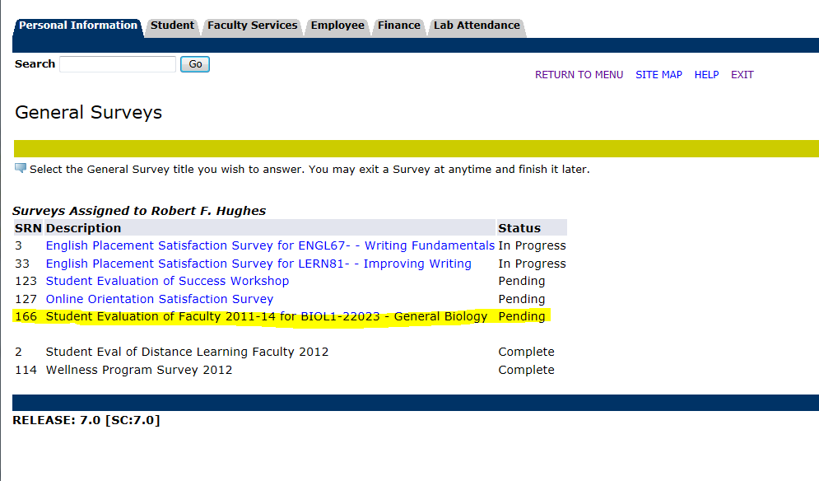

1. When the student clicks on the link, the evaluation instrument will be displayed. Students have the ability to click the button at the bottom of the page to 'Finish Later'. This marks their evaluation as 'In Progress', giving them the ability to return to it any time prior to the *To Date*. When the student clicks the 'Complete' button, the evaluation is submitted and no additional updates or changes are allowed.

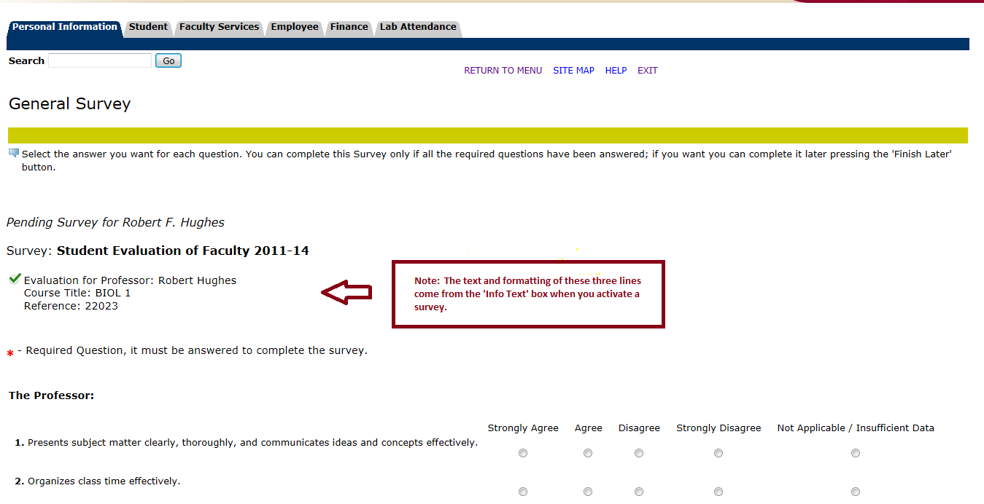

1. Instructors will receive a confirmation e-mail the end of the day after activating an evaluation and a progress e-mail every other day. At the end of the *To Date*, instructors will receive a compiled evaluation report and a list of students who completed the evaluation.