

DATE: July 28, 2017

TO: Responsible and Concerned Agencies

SUBJECT: Notice of Completion (NOC) of the Mt. San Antonio College West Parcel Solar Project Tiered Draft Environmental Impact Report (SCH 2002041161)

FROM: Rebecca Mitchell, Manager

Facilities Planning & Management

Mt. San Antonio College

1100 North Grand Avenue

Walnut, California 91789-1399

The Mt. San Antonio Community College District (District) is the lead agency and has prepared a Tiered Draft Environmental Impact Report (Draft SEIR) for the Mt. San Antonio College West Parcel Solar Project (West Parcel Solar Project) under the terms and requirements of the California Environmental Quality Act (CEQA) and the implementing CEQA regulations. The project site is located on campus west of Grand Avenue and south of Amar Road and Temple Avenue.

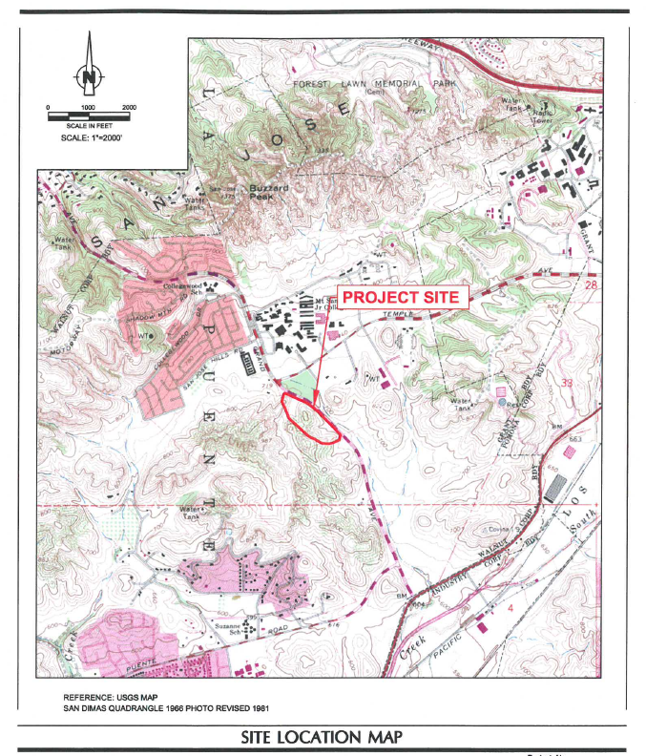

The Draft SEIR is tiered to the 2012 Master Plan’s Subsequent Environmental Impact Report (“2012 Master Plan EIR”) (SCH 2002041161) certified as a programmatic EIR by action of the District Board of Trustees in December 2013 and the 2015 Facilities Master Plan Update and Physical Education Projects (PEP) Subsequent Program/Project Environmental Impact Report (“2015 Master Plan EIR”) certified as a Program/Project EIR (SCH 2002041161) by action of the District Board of Trustees in October 2016.

The West Parcel Solar Project is located on a 27.65-acre parcel located west of Grand Avenue zoned Solar & Retail. The 27.65-acre parcel contains primarily coastal sage scrub, habitat for the threatened coastal California gnatcatcher. Replacement and restored habitat will be implemented onsite and east of Grand Avenue. Grading will occur on 17.25 acres to create a 9.9 acre pad at 761 feet mean sea level for a 2.2 MW ground-mounted solar panel system. Earth import for the project from the stadium area of the campus is estimated as 139,000 cubic yards.

The potential environmental impacts of the West Parcel Solar Project are evaluated in the Draft SEIR posted on the District’s website (see below for website address). A summary of potential project impacts, recommended mitigation measures and the status of the impacts with mitigation (i.e. Less than Significant with Mitigation Incorporated, etc.) is included in Table 1.4.1 in Volume 1. All technical studies, notices and correspondence are included in Volume 2: Appendices.

Documents Available for Review:

The Draft SEIR documents (Volumes 1, 2) are posted on the District’s website:

<http://www.mtsac.edu/construction/reports-and-publications/environmental-impact-reports.html>

The Draft EIR may also be reviewed at the following locations:

Walnut Public Library Mt. San Antonio College Library

Reference Desk Building 6, Library, 2nd floor, Reference Desk

21155 La Puente Avenue 1100 North Grand Avenue

Walnut, California 91789 Walnut, California 91789

Time for Review:

The Draft EIR is being circulated for a 45-day public review period from July 28, 2017 to September 12, 2017. All comments on the Draft EIR must be received by 5:00 pm on Tuesday, September 12, 2017.

All public comments should be forwarded as written correspondence or pdf attachments to e-mails. **Freestanding e-mail comments are discouraged**. Please include the name and full mailing address of the respondent in all communication, and the date the comments are sent. If an agency is responding, please provide a person, e-mail address and phone number.

Please send your comments to Rebecca Mitchell, Manager, Facilities Support Services at the address below:

Project Title: Mt. San Antonio College Physical Education Project (Phase 1, 2)

Project Applicant: Mt. San Antonio Community College District

Date: July 28, 2016

Contact: Rebecca Mitchell

Telephone: (909) 274-5175

Facsimile: (909) 274-2931

E-Mail Address: [facilitiesplanning@mtsac.edu](mailto:facilitiesplanning@mtsac.edu)

Comments Due: 5:00 pm on Tuesday, September 12, 2017