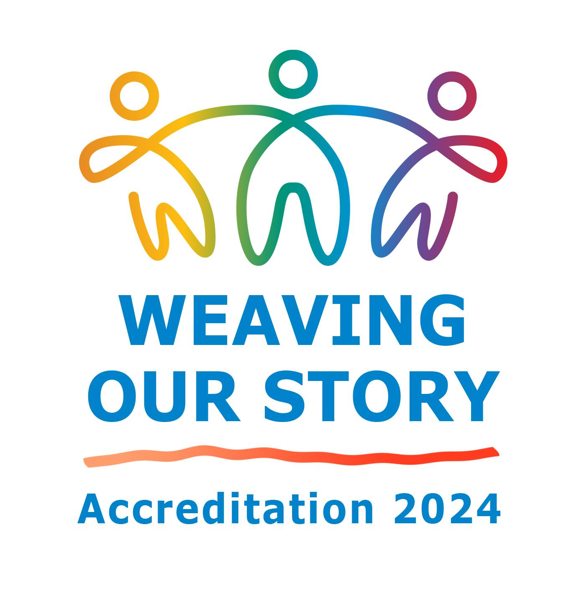

PAC Meeting June 8, 2022

- Update on what the Accreditation Team has done

Accreditation Website

URL: https://www.mtsac.edu/accreditation/college_accreditation/2024/index.html

Highlights:
- Over 100 Weaving Team participants
- Weaving Teams are on track to finish drafts before summer
- Three college forums
  - “Accreditation with Class” for classified professionals
  - “DE Accreditation Forum” presented with DLC members and input
- Student Accreditation Training for Weaving Team participants
  - Presented by Amber Nuno and Matthew Sosa
- Accreditation SWAG is available

- Issues that PAC may be able to help with:

- The last comprehensive review of BPs and APs was August 17, 2016
  - Is there a plan to review these again?
- The committee and council webpages are not up to date.
- The minutes and agendas for committees and councils are not all accessible.
  - One suggestion: an accessible template that all committees and councils could use

- Plans in progress

- Summer Accreditation “work days”
  - July 11 9:00 am - 5:00 pm
  - July 27 1:30 pm - 5:30 pm
- FLEX Day presentation in the Fall on DE
- Finishing Team and Resource Team review of drafts in the fall

