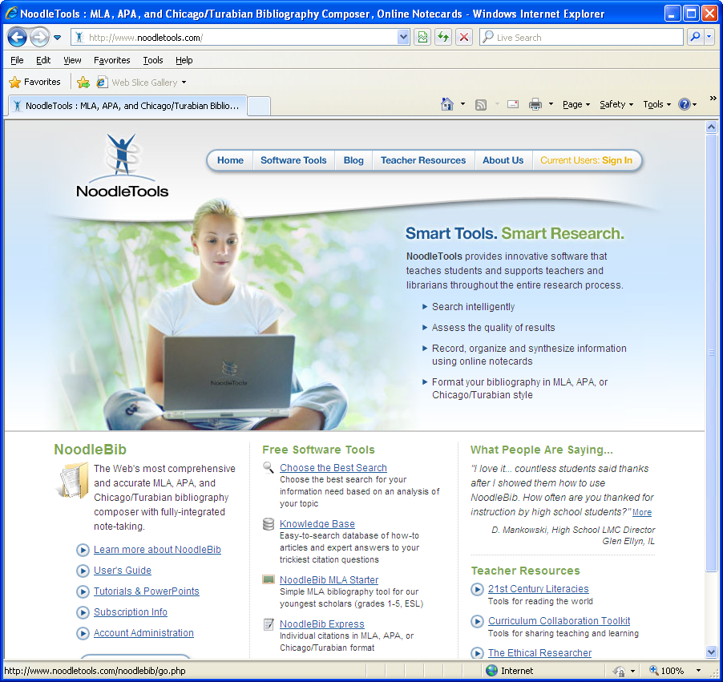
Browse to Noodletools.com
Click Current Users: Sign In

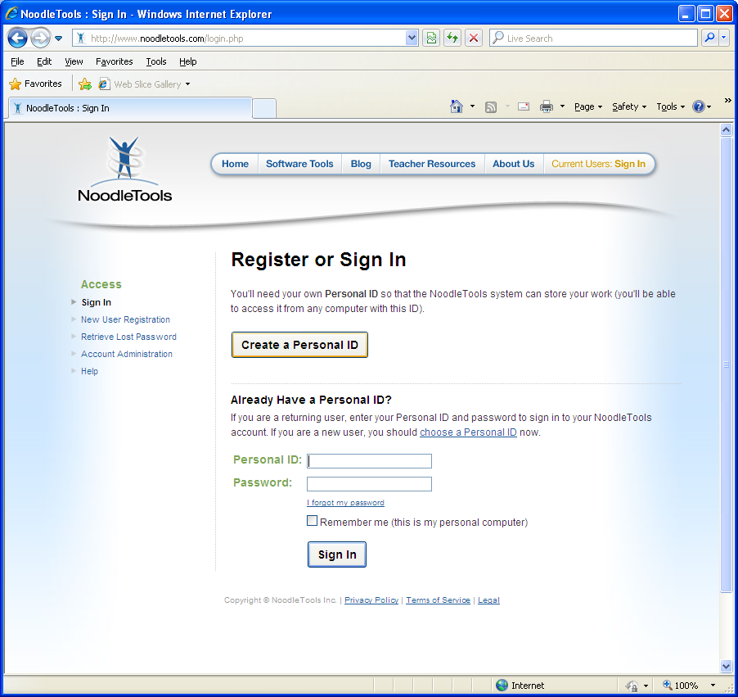
Click Create a Personal ID
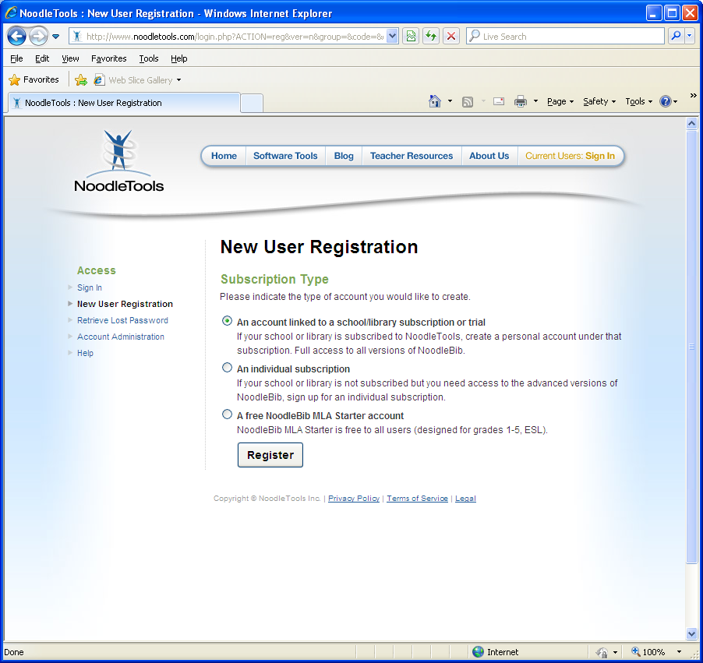
Select “An account linked to a school/library subscription or trial”
Click Register
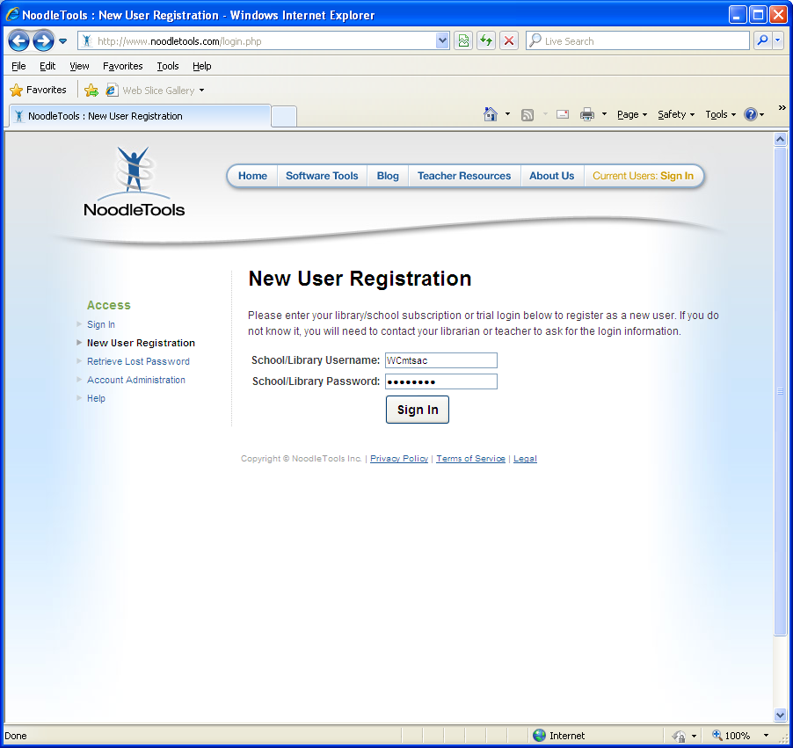
School/Library Username: WCmtsac
School/Library Password: password
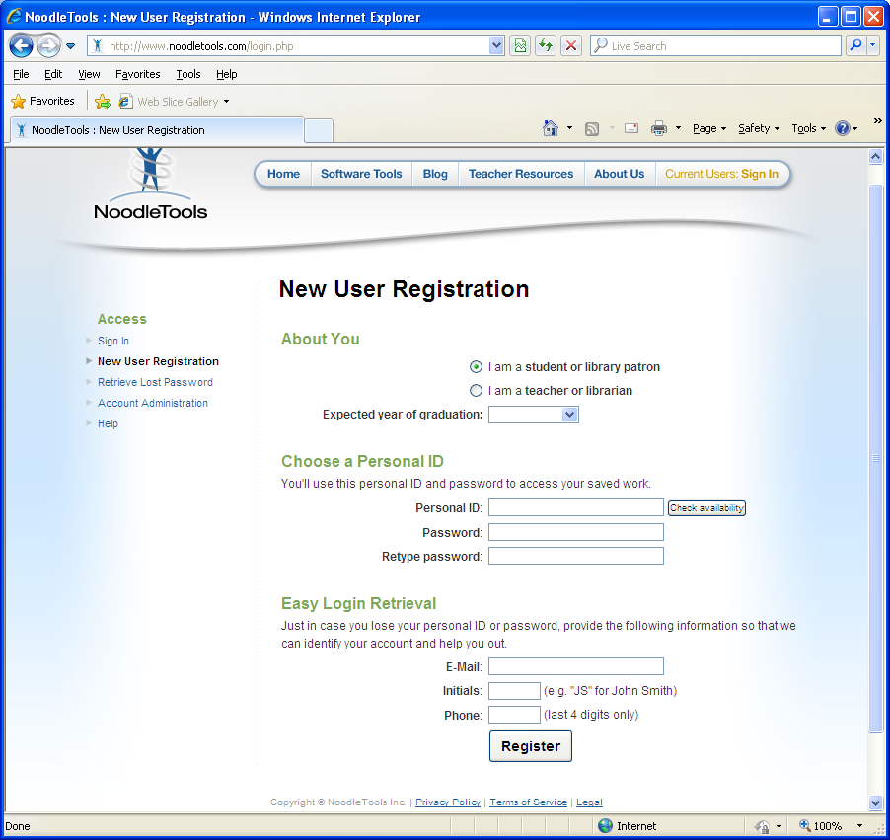
Enter your information
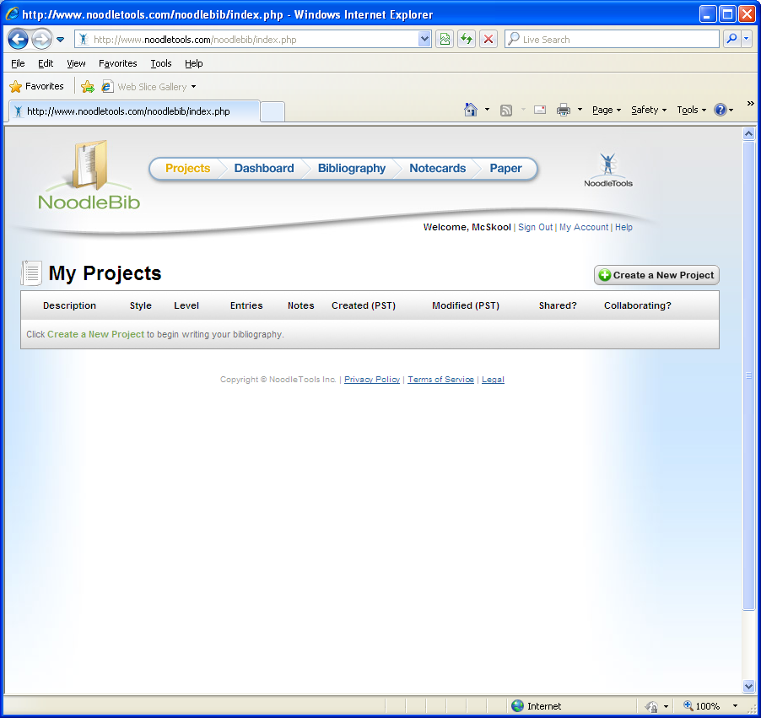You’re in!

