Articles
Student Name:
Instructor:
Date:
Course:

About This DLA

Important Note
All the activities (3) in the DLA must be completed in their entirety before receiving credit for completion. Students are welcome to meet with a tutor if they need help, but please be aware that students might need a second appointment for review and signature in that case. If your instructor wants evidence of this completed DLA, return this form to him or her with the tutor’s signature included.

Learning Outcomes
Through computer and other independent work, this activity will familiarize you with articles and help you better understand their function in language.

Activities (approximately 1 hour)
Read the information, complete the activities that follow, and be prepared to discuss your answers when you meet with a tutor.

Understanding Articles
Articles are words used to introduce or identify a noun. You must always have an article before a singular count noun.
Correct: It’s a camera.
Incorrect: It’s camera.
English has two articles: a(n) and the. The is used to refer to specific or particular nouns (definite); a(n) is used to modify non-specific or non-particular nouns (indefinite).
- Let's watch a movie. (any movie, not a specific movie)
- Let's watch the movie. (a specific movie I have already mentioned in our conversation)

Indefinite Articles A(n)
The articles a and an signal that the noun being modified is indefinite, referring to any member of a group. For example:
- I want to buy a house. (any house, not a specific house)
The indefinite articles are used to say what someone or something is:
- I am a teacher.
- Is it a camera? Is it a phone? No, it’s a camera phone.
The indefinite articles are used to mention something for the first time.
- Look! There is a man outside. (first mention of the man)

A vs. A(n)
Using a or an depends on the sound that the next word begins with.
- a words beginning with a consonant: a zoo; a good car; a year
- an words beginning with a vowel: an elephant; an apple; an excellent question
- an words starting with silent "h": an hour, an honest opinion
- a words starting with a pronounced "h": a hospital, a heroic effort
- a words that begin with consonant "y" sound: a European, a unique laugh

Some as an Indefinite Article
Some may be used as an indefinite article for plural count nouns and non-count nouns.
- Joe borrowed some books yesterday. (plural count noun; the books he borrowed are not specified)
- I need to get some information for my essay topic. (non-count noun; the information is not specific)

Definite Article The
The definite article is used before singular and plural nouns when the noun is specific. This signals that the noun is definite, that it refers to a particular member of a group.
- The dog that bit me ran away. (a specific dog: the dog that bit me)
With plural count nouns, use the when you mean something specific; do not use an article when you mean something in general.
- The orchids at my grandmother’s house are gorgeous. (these specific orchids)
- Orchids are gorgeous. (all orchids in general)
The definite article is also used for the second (or subsequent) mention of something.
- I saw a man and a woman outside. (first mention) The man was wearing a hat and the woman was wearing a blue dress. (second mention)

Count & Non-count Nouns
The can be used with non-count nouns (abstract things or things that are too small or unable to be counted), or the article can be omitted entirely.
- I love bread. (general)
- Please pass the bread. (specific—the bread that is on the table)
A(n) can be used only with singular count nouns.
- I need a bottle of water.

Uses of The
Use the before:
- times of day: the morning, the afternoon, the evening (except night)
- names of rivers, oceans and seas: the Nile, the Pacific
- points on the globe: the Equator, the North Pole
- geographical areas: the Middle East, the West
- deserts, mountain ranges, forests, gulfs, and peninsulas: the Sahara, the Himalayas, the Black Forest, the Persian Gulf, the Yucatan Peninsula
- musical instruments and scientific inventions: the guitar, the radio, the internet
- the superlative form: the best class, the worst experience, the most intelligent student
- before some adjectives with a general meaning: the rich, the poor, the elderly
- when there is only one of something: the Pope, the moon, the Earth
- some expressions with the have a general meaning: the beach, the desert, the forest, the countryside, the mountains, the rain, the wind, and the snow

Zero Article Ø
We do not use the indefinite articles (a/an) with non-count nouns, or with plural count nouns.
- What’s in that cup? It’s milk and sugar. (non-count nouns)
- These are kumquats. (plural count nouns)
Some common types of nouns that don't take an article are:
- names of languages and nationalities: Chinese, English, Spanish, French (unless you are referring to the people of the nation: "The French love cheese.")
- meals: breakfast, lunch, dinner
- names of sports: soccer, tennis, baseball
- names of academic subjects: mathematics, biology, history, computer science
- months and days of the week: March, Tuesday
- with some nouns when we are thinking about the purpose of the place: school, college, church, class, prison, jail, home, bed
- names of most countries/territories: India, Mexico, China (except names with count nouns or plural names, the Netherlands, the Dominican Republic, the Philippines, the United States, the United Arab Emirates)
- names of cities, towns, or states: Walnut, Oregon, Miami (except when the name acts as an adjectiveThe Miami Airport)
- names of streets: Grand Ave., Tenth St.
- names of individual lakes and bays: Lake Superior, Lake Erie (except with a group of lakes like the Great Lakes)
- names of mountains: Mount San Antonio, Mount Everest
- names of continents: Asia, Europe
- names of islands: Easter Island, Maui, Key West (except with island groups like the Hawaiian Islands, the Bahamas, or the Azores)

Article Reference Chart
Use the following chart as a quick reference for whether an article is necessary or not.
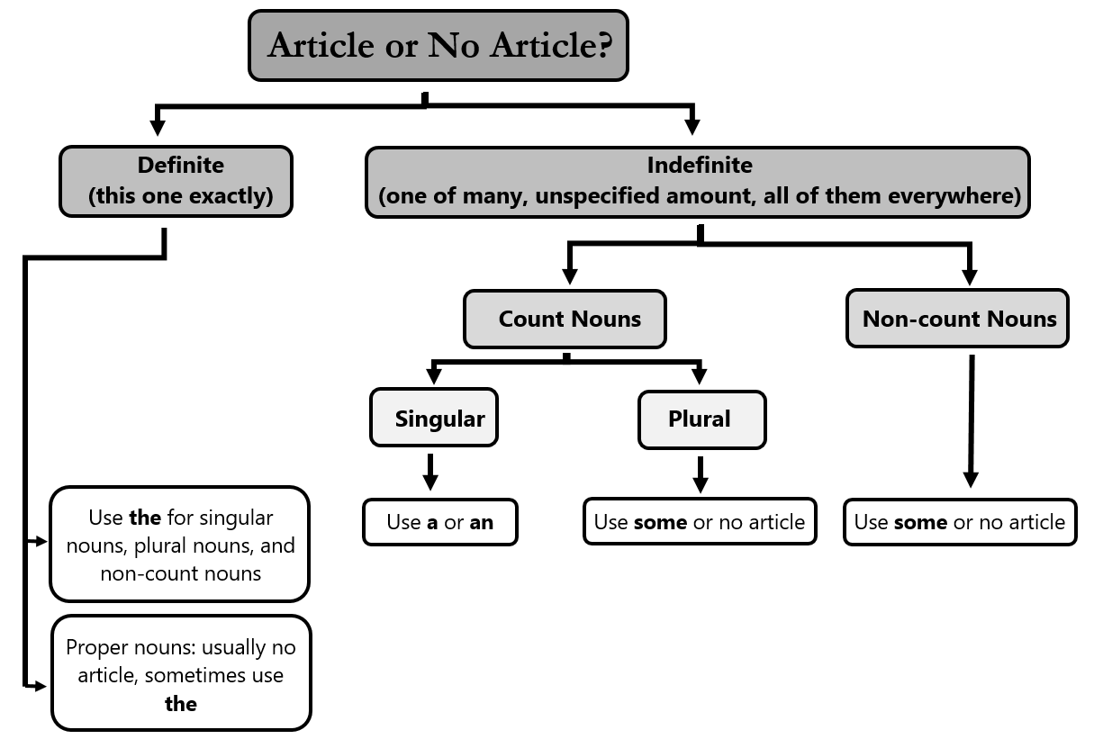

Activities (Approximately 1 Hour)
Follow the steps below and be prepared to explain your answers when you meet with a tutor. Check off each box once you have completed the activity.

☐ 1. Online Quiz
Go to http://tinyurl.com/ArticlesDLA and take the Articles DLA Quiz. After you complete the task, PLEASE ASK A LAB TUTOR OR FRONT DESK ATTENDANT TO PRINT THE PAGE THAT HAS YOUR SCORE. DO NOT EXIT THE PROGRAM UNTIL THIS PAGE HAS BEEN PRINTED (FREE OF CHARGE).

☐ 2. Identifying Articles and Correcting Errors
Review the above information on articles, and then read the following sentences. Identify whether each is correct (C) or has article errors (Art.). If there are errors, correct them.
Read each sentence below. | Type your answer in the spaces below.
1. L.E. loves going to beach during her time off. | 1.
2. Dana has a hour lunch break. | 2.
3. I’m working on Tuesday and playing basketball after lunch on Saturday. | 3.
4. Keys that are on table belong to Mary. | 4.
5. I had dinner at Chez Yann. I really liked the sautéed mushrooms there. | 5.
6. The love is most wonderful feeling. | 6.
7. Michael is at the school right now. | 7.
8. Robert doesn’t have the bike, so he walks to school. | 8.
9. I met a couple at school. I didn’t like a man, but woman was nice. | 9.
10. I bought the car that your sister was selling. | 10.

Choose 3a or 3b Below

☐ 3a. Correct Your Own Writing
Collect some of your graded work that identifies article errors. Correct all marked errors and look for others to correct as well. Bring this revised work with you to the DLA tutoring session.
OR
If you do not have your own essay to work with, please complete the supplemental activity below (3b).

☐ 3b. Adding the Missing Articles
The following paragraph is missing articles. Read it, and then add the articles a, an, the wherever they are needed.
Freaky Friday
On Friday, while I was sitting in my biology class, I heard loud noise in hallway. Sound was similar to dog yelping, and I got scared. All of a sudden, I saw person’s face peer through window of classroom door. I jumped up in my seat and started to sweat. Face then disappeared. I looked around to see if other students had noticed, but they were busy with their classwork. I asked teacher for permission to go to restroom and stepped out of class. I looked out into hallway and there was nothing on either side. As I was walking toward restroom, I heard footsteps following behind me. I didn’t dare to look back because I was too afraid. I slowed down, and then footsteps slowed down. When I sped up, footsteps did, too. I then dashed out school doors as fast as I could. I ran towards forest behind schoolyard without even looking back. Unfortunately, I tripped on old tree branch, and world turned upside down. I tumbled a few times down an embankment into dry riverbed. I quickly sprung to my feet and kept running until I was out of breath. I stopped to catch my breath when suddenly I felt eerie hand on my shoulder. My heart dropped as I turned slowly to see who was there. I jumped so violently that I woke up and found myself sitting in my chair in my biology class. Classmate was tapping my shoulder because I had fallen asleep in middle of class. Whole class was looking at me and laughing a little. I have never felt so embarrassed in my life!

☐ 4. Review
Go to https://mtsac2.mywconline.com and use the Mt. SAC Writing Center Appointment System to make a DLA appointment, or sign-up to see a tutor on the “Walk-in” list in the Writing Center. During your session with a tutor, explain articles. Refer to your own graded writing (or the completed activity) and explain to the tutor strategies that you used to identify articles and how knowledge of these concepts can help improve your writing style.
Sign and date in the space below.
Student’s signature: | Date:
Tutor’s Signature: | Date:
If you are an individual with a disability and need a greater level of accessibility for any document in The Writing Center or on The Writing Center’s website, please contact the Mt. SAC Accessible Resource Centers for Students, access@mtsac.edu, (909) 274-4290.
Revised 04/12/2022

