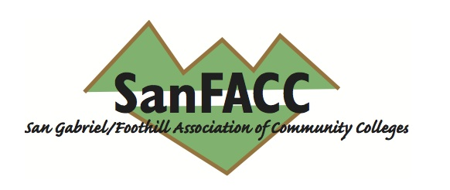

We are now accepting applications for the 2018-2019 year.

The SanFACC Mentor program seeks to build both individual and regional leadership capacity among current full-time/permanent employees. Mentees with a clear interest in entering or advancing in community college management will be paired with mentors from neighboring colleges already serving in an administrative role. This experience provides a safe environment to develop a knowledge base that supports effective leadership and management. Participants are enriched by experiencing the best practices and lessons learned from colleagues across the region.

This program is open to all full-time/permanent employees within a community college who are seriously considering moving into or advancing into an administrative position in a community college. Applications are due March 28, 2018. Contact [coordinator].

Application: https://form.jotform.com/SanFACC/app
Supervisor Acknowledgement Form: https://form.jotform.com/SanFACC/supervisor
Recommendation Form: https://form.jotform.com/SanFACC/recommend

The program is sponsored by the San Gabriel/ Foothill Association of Community Colleges:

