SLP15. Daily Routine

Pair #
STOP: Before you begin this activity, open and follow recording instructions here.

Partner A:
Student ID:
Instructor:
Language:
Level: Date:
Partner B:
Student ID:
Instructor:
Language:
Level: Date:

WAIT! If you have not learned how to tell time in your target language yet, you may want to complete LP7 before you complete LP15.

Section 1: Vocabulary Mastery
Instructions: Describe the sign of the following words and phrases using the 5 Parameters of ASL. Try to use your book and your partner before using other materials or the internet. Use the third column to help you remember the sign in your target language (ASL) by drawing a picture or writing a note to yourself.
Vocabulary | 5 Parameters of ASL Description | Notes/Pictures/Sign Guide  (anything to help you)
- To wake up
- To shower
- To brush one’s teeth
- To brush one’s hair
- To get dressed
- To eat (breakfast/lunch/ dinner)
- To go to sleep
- To put on makeup
- To work
- To go to school
- To go shopping
- To study
- To watch TV
- To read a book
- To walk the dog

Section 2: ASL Syntax
Instructions: Write the following using ASL word order. Try to use your book and your partner before using other materials or the internet.
- When do you get up?

- My mom wakes up at 7:00am and takes a shower.
- Camila brushes her hair and puts on makeup.
- Camila studies at 5pm on Tuesdays.
- When do you go to sleep?
- I go to sleep at 11pm.

Section 3: What is Jackson’s Daily Routine?
Instructions: Look at the pictures to learn about Jackson’s daily routine. Then, write the questions using ASL syntax (word order) on the following page. Take turns asking and answering the questions with your partner using the pictures.
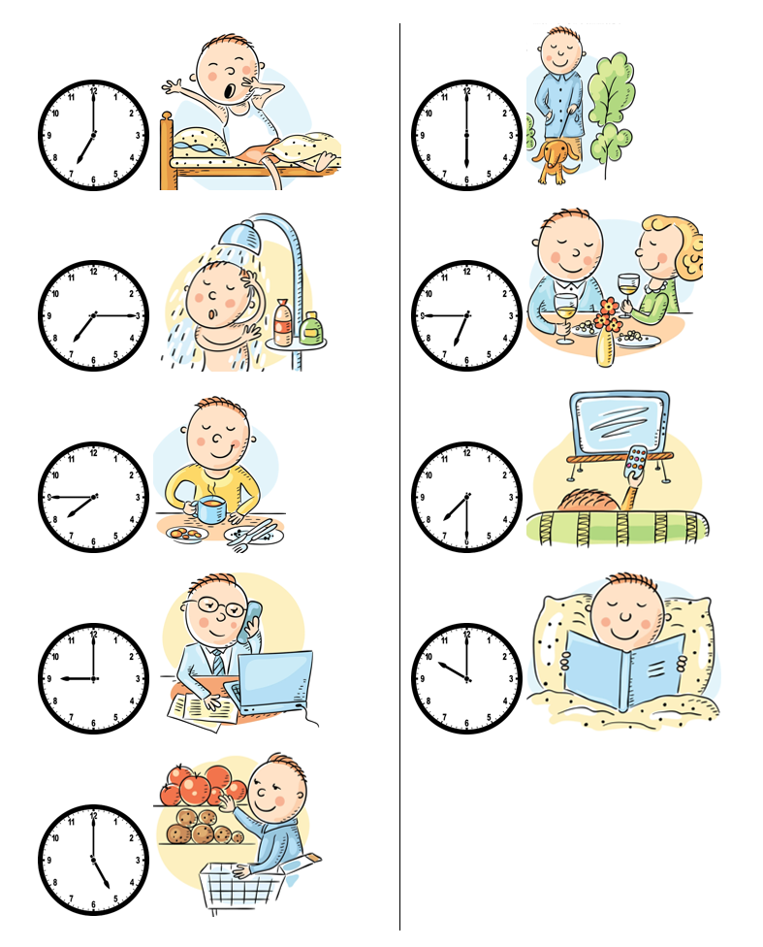

Instructions (continued from page 3): Write the questions on this page in ASL word order. Try to use your book and your partner before using other materials to help you. Take turns asking and answering the questions with your partner using the pictures from page 3.
- When does Jackson wake up?
- What does Jackson do at 7:15AM?
- When does Jackson eat breakfast?
- What does Jackson do at 9:00AM?
- When does Jackson go shopping?
- What does Jackson do at 6:00PM?
- What does Jackson do at 6:45PM?
- When does Jackson watch TV?
- What does Jackson do at 10:00PM?

Section 4: Creating a Dialogue
Instructions: You and your partner will ask and tell each other about your daily routine. You can ask questions similar to the ones on the previous page, but make sure to use “you” forms instead of “he/she.” Write your conversation here. Attach another piece of paper if you need more space. You will record this dialogue in the next section. Ask for help when necessary.
Signer 1:
Signer 2:
Signer 1:
Signer 2:
Signer 1:
Signer 2:
Signer 1:
Signer 2:

