SLP8. Friends and Emotions

Pair #
STOP: Before you begin this activity, open and follow recording instructions here.

Partner A:
Student ID:
Instructor:
Language:
Level: Date:
Partner B:
Student ID:
Instructor:
Language:
Level: Date:

Section 1: Vocabulary Mastery
Instructions: Describe the sign of the following words and phrases using the 5 Parameters of ASL. Try to use your book and your partner before using other materials or the internet Use the third column to help you remember the sign in your target language (ASL) by drawing a picture or writing a note to yourself.
Vocabulary | 5 Parameters of ASL Description | Notes/Pictures/Sign Guide  (anything to help you)
- I am
- You are (singular/plural, formal/informal if applicable)
- He is
- She is
- We are
- They are
- Happy/sad
- Disgusted /angry
- Gentle/kind/funny/patient
- Optimistic/pessimistic
- Afraid/arrogant
- Lazy/selfish/bossy/energetic/active
- Responsible/smart
- Beautiful/ugly
- Modern/old/antique
- Rich/poor
- Slim/thin/fat

Section 2: Identify Emotions
Instructions: Label the following traits using the vocabulary from Section 1. Use your target language.
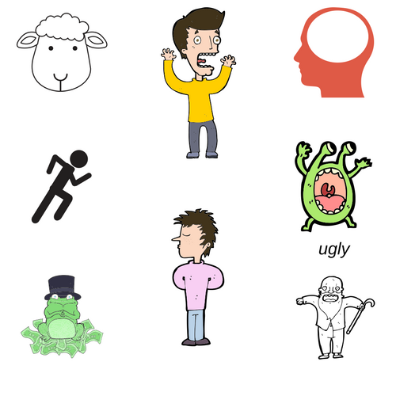

Section 3: Sentence Completion
Instructions: Take turns finishing these sentences and writing them using ASL syntax (word order). Practice signing with your partner.
Example: Today I feel excited.
- Today I feel: __________________________________________
- Yesterday I felt: ________________________________________
- After class I feel: _______________________________________
- After I study I feel: _____________________________________
- After work I feel: ______________________________________
- I like people who are: ___________________________________
- My friends are: ________________________________________
- I dislike people who are: _________________________________
- Today my mom is: _____________________________________
- Today my dad is: _______________________

Section 4: Dialogue Creation
Instructions: Your partner will ask you about a friend. Find a picture of a friend or family member on your phone. Use three adjectives to describe your friend. Switch roles and ask your partner about a friend. Write your conversation here. Attach another piece of paper if you need more space. You will record this dialogue in the next section. Ask for help when necessary.
Signer 1:
Signer 2:
Signer 1:
Signer 2:
Signer 1:
Signer 2:
Signer 1:
Signer 2:

