SLP4. Hometown

Pair #
STOP: Before you begin this activity, open and follow recording instructions here.

Partner A:
Student ID:
Instructor:
Language:
Level: Date:
Partner B:
Student ID:
Instructor:
Language:
Level: Date:

Section 1: Vocabulary Mastery
Instructions: Describe the sign of the following words and phrases using the 5 Parameters of ASL. Try to use your book and your partner before using other materials or the internet. Use the third column to help you remember the sign in your target language (ASL) by drawing a picture or writing a note to yourself.
Vocabulary | 5 Parameters of ASL Description | Notes/Pictures/Sign Guide (anything to help you)
- an airport
- a hotel
- a bank
- a bar
- a library
- a gym
- a restaurant
- a university
- a train station
- a supermarket
- a theater
- a post office
- a gas station
- a coffee shop
- There is/are . . .
- Where is . . . .?
- My hometown is a . . .
(city, town, village, etc.)

Section 2: Sentences and Questions
Instructions: Write the expressions that are used when talking about a city, a town, or a village using ASL syntax (word order). Answer the questions using ASL syntax. Practice signing the questions and answering. Take turns with your partner.
Is your hometown big or small?

Where is your favorite coffee shop?

Does your town have a theater?

How many schools does the city have?

Where is a good place to study?

What do you do on the weekends in your hometown?

What is your favorite restaurant in your hometown?

Section 3: Practice with a Map
Instructions: Label the map and describe this city in ASL. Practice signing with your partner taking turns. 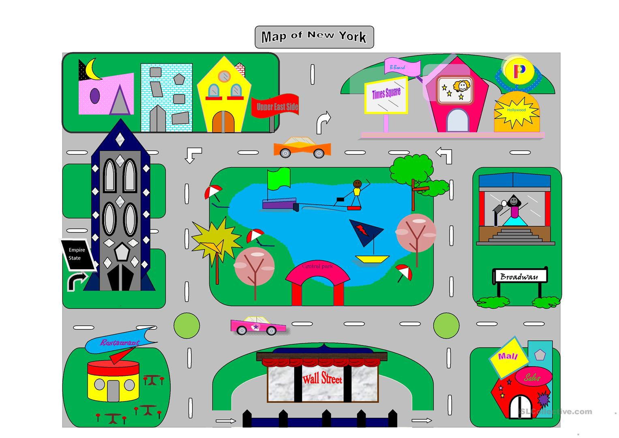

Section 4: Dialogue Creation
Instructions: Write the questions you will ask your partner about their own house using ASL syntax (word order). Then write your partner’s answers using ASL syntax. Practice asking and answering. Switch roles and then answer your partner’s questions. Attach another piece of paper if you need more space. You will record this dialogue in the next section. Ask for help when necessary.
Signer 1:
Signer 2:
Signer 1:
Signer 2:
Signer 1:
Signer 2:
Signer 1:
Signer 2:

