SLP11. Seasons and Weather

Pair #
STOP: Before you begin this activity, open and follow recording instructions here.

Partner A:
Student ID:
Instructor:
Language:
Level: Date:
Partner B:
Student ID:
Instructor:
Language:
Level: Date:

Section 1: Vocabulary Mastery
Instructions: Describe the sign of the following words and phrases using the 5 Parameters of ASL. Try to use your book and your partner before using other materials or the internet. Use the third column to help you remember the sign in your target language (ASL) by drawing a picture or writing a note to yourself.
Vocabulary | 5 Parameters of ASL Description | Notes/Pictures/Sign Guide  (anything to help you)
- Spring, Summer
- Fall, Winter
- January, February, March
- April, May, June
- July, August, September
- October, November, December
- What’s the weather like today?
- The weather is good/bad.
- It’s sunny.
- It’s calm.
- It’s hot.
- It’s cloudy.
- It’s raining./It’s pouring.
- It’s windy.
- It’s snowing.

Section 2: Signed Expressions
Instructions: Write these questions about weather using ASL syntax (word order). Practice asking and answering in the target language (ASL).
What is the weather in Walnut, CA?
Which months are a part of summer in California?
When does it rain in Walnut?
In Southern California, December is
In Southern California, September is
In Southern California, April is

Section 3: Weather around the World
Instructions: Go to a weather app on your phone OR https://www.accuweather.com/en/world-weather. Click on each city to get more information. Write a couple words to describe the weather in the cities below. With your partner, practice asking and answering about today’s weather in these cities in the target language (ASL).

Example: Los Angeles
Write: hot, sunny
Speak: What’s the weather in Los Angeles today? It is hot in Los Angeles. It is sunny.

Paris, France:
Beijing, China:
Tokyo, Japan:
Sydney, Australia:
Mexico City, Mexico
Moscow, Russia
Mumbai, India:
Cairo, Egypt:
Madrid, Spain:
Buenos Aires, Argentina:

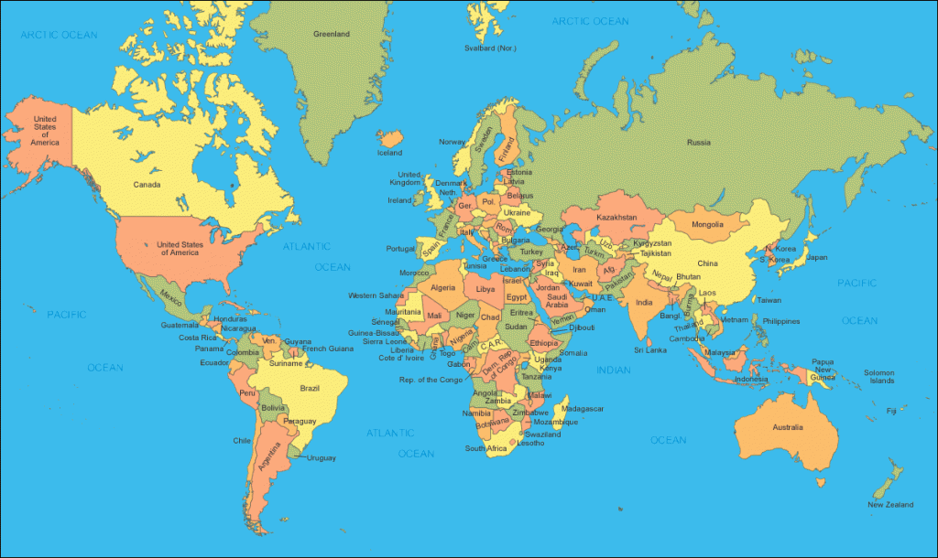

Section 4: Creating a Dialogue
Instructions: Ask your partner about the weather in their hometown or favorite city. Then switch roles and answer your partner’s questions about the weather in your hometown or favorite city. Write your conversation here. Attach another piece of paper if you need more space. You will record this dialogue in the next section. Ask for help when necessary.
Signer 1:
Signer 2:
Signer 1:
Signer 2:
Signer 1:
Signer 2:
Signer 1:
Signer 2:

