LP20 Household Chores

Pair #
STOP: Before you begin this activity, open and follow recording instructions here.

Partner A:
Student ID:
Instructor:
Language:
Level: Date:
Partner B:
Student ID:
Instructor:
Language:
Level: Date:

Section 1: Vocabulary Mastery
Instructions: Write the translation of the following words and phrases into the language you are studying. Write the translation above or beside the image. Try to use your book and your partner before using other materials. Then translate the entire paragraph.

(1) is boring. So, I just toss
(2) .
My mom (3) the meals (4) , and my sister cleans up afterwards. She
(5) , and puts food away in the (6) .
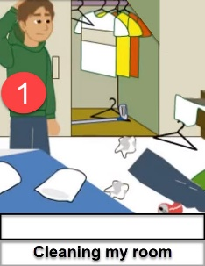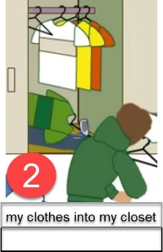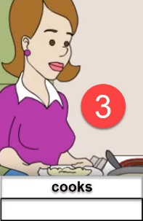
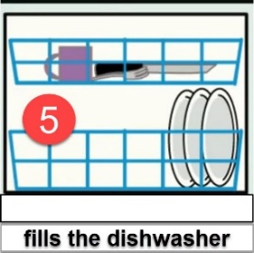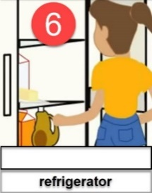
It’s (7) my chore to
(8) and (9) .
(10) , we have to clean the house. My older brother only
(11) . At the same time, I
(12) . I can’t complain because my sister
(13) ,
(14) , and (15) . Next time, I want my brother’s
(16) .
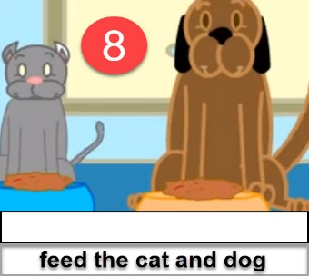 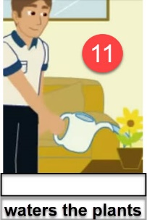 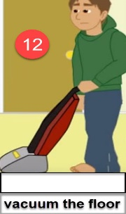
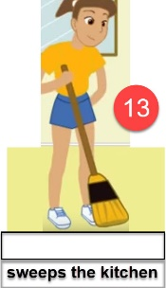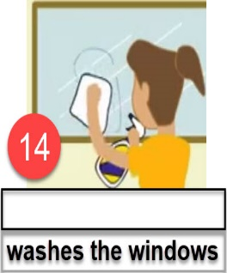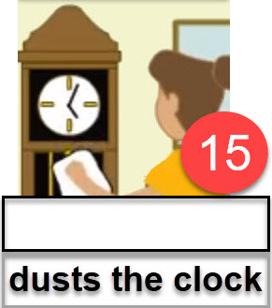

Section 1B: Vocabulary Mastery
Instructions: Write out your translation of the paragraph here.

Section 2: Vocabulary Madlibs: A Silly Story
Instructions: Now that you have translated the words and phrases in the correct order for the paragraph in Section 1A, you are going to mix it up. Take turns with your partner to create new sentences. The new sentences do not have to make sense. Have fun with it! For example, partner A would ask partner B to use phrase #14 in space #1. Then partner B would ask partner A to use phrase #16 in space #6. Continue back and forth for all 16 spaces. Try to fill verb spaces with verbs, noun spaces with nouns, and so on so the grammar is logical, even if the meaning is silly. Write your final version of the paragraph below.
Explanation: Your brain works hard to make sense of language. Therefore, by creating non-sensical or unusual sentences, your brain will work extra hard to remember the related vocabulary.

Section 3: Question and Answer
Instructions: Take turns answering these questions in the language you are studying. Upper levels should translate the questions into the language you are studying as well as the answers. Practice asking and answering.

- What chores do you do around your house?
- What housework should you do every week?
- What are some outdoor chores some people do?
- Which chore do you like the most?
- Which chore is your least favorite?

Section 4: Creating a Dialogue
Instructions: Create a brief dialogue with your partner about the household chores you normally do and which ones you don’t do. If possible, explain why you do some activities and why you don’t do others. You can also explain why some are your favorites. Include where you do them and how often. Your conversation should be 2-4 minutes long. Write your conversation here. Make notes on the next page if you need more space. You will perform this dialogue in the next section.
Speaker 1:
Speaker 2:
Speaker 1:
Speaker 2:
Speaker 1:
Speaker 2:
Speaker 1:
Speaker 2:
Speaker 1:
Speaker 2:
Speaker 1:
Speaker 2:
Speaker 1:
Speaker 2:

Section 5: Perform Your Dialogue
Instructions: Perform the dialogue you created with your partner. Make sure you do not end your Zoom meeting until you have performed your dialogue with your partner.

