KLP19 Travel
STOP: Before you begin this activity, open and follow recording instructions for online activities or on-campus activities.

Pair # __________

Partner A: ________________________________
Student ID: _______________________________
Instructor: ________________________________
Level: ______________ Date: _________________
Partner B: ________________________________
Student ID: _______________________________
Instructor: ________________________________
Level: ______________ Date: _________________

Section 1: Vocabulary Mastery
Instructions: Write the translation of the following words and phrases into Korean. Try to use your book and your partner before using other materials or the Internet. In the third column, draw a picture, write a note to yourself or put some kind of pronunciation guide for the target language. Use the third column to help remember your target language.
Vocabulary | Translation | Notes/Pictures/Pronunciation Guide (anything to help you)
- Domestic flight
- International flight
- Passport
- Travel agency
- Round trip
- One way trip
- Ticket
- The old days
- Korean straw shoes
- Korean earthen jars
- Vegetarian / vegan
- Snack shop or restaurant
- To be sad
- To change
- To reserve (tickets)
- To pack (luggage)
- To go and get back
- To get around
- To arrive
- To depart

Concept Check: Past Tense Doubling of ~었
The simple past is indicated by ~ㅆ어요. It states something that is done in the past. The doubling of ~었is used when you want to focus on a past event that is no longer true in the present moment.
To conjugate a past tense that is no longer true, all you have to do is add extra ~었from the simple past tense:
Simple past Doubling of ~었
먹다 먹었어요 먹었었어요
마시다 마셨어요 마셨었어요
전화하다 전화했어요 전화했었어요
말하다 말했어요 말했었어요
돈을 쓰다 돈을 썼어요 돈을 썼었어요
테니스를 치다 테니스를 쳤어요 테니스를 쳤었어요
공부하다 공부했어요 공부했었어요
The difference in meaning is clear between the two past tenses. For example, you are talking to your friend about a mutual friend Yumi.
리사: 유미는 어떻게 지내요?
소피아: 한국에 갔어요.
리사: 아, 그래요?
In this conversation, it is not clear whether Yumi is still in Korea or not. She went to Korea and she could still be in Korea or not. She could be some place else. However, look at the same conversation using the doubling of ~었.
리사: 유미는 어떻게 지내요?
소피아: 한국에 갔었어요.
리사: 아, 그래요?
In this conversation, it is clear that Yumi was in Korea but is no longer in Korea. This sentence implies that she went to Korea and came back. She is not in Korea anymore.
The doubling of ~었indicates something that was true in the past but no longer true in the present. If you want to talk about how you used to play the piano but you don’t play anymore, you can use this doubling of ~었.
고등학교 때 테니스를 쳤었어요.
This above sentence means “I played tennis when I was in high school” but I don’t anymore.

Section 2: Sentence Translation
Instructions: Take turns translating the following sentences into Korean. Then practice asking and answering. Write down your partner’s answers in Korean. Remember to use the doubling of ~었to ask and answer.
- What did you do during school vacation?
____________________________________________________________________________
- What sports did you play during high school?
____________________________________________________________________________
- Where were you during school vacation?
____________________________________________________________________________
- What did you like during junior high?
___________________________________________________________________________________________
- What did you eat when you were young?
____________________________________________________________________________
- Where did you live (what city) during elementary school?
____________________________________________________________________________
- What subjects did you like during high school?
____________________________________________________________________________
- What was your hobby in the past?
____________________________________________________________________________

Section 3: Not Anymore!
Instructions: Look at each picture and discuss with your partner things that you or Koreans used to do but not anymore and state what it is that you or Koreans do.
Example:
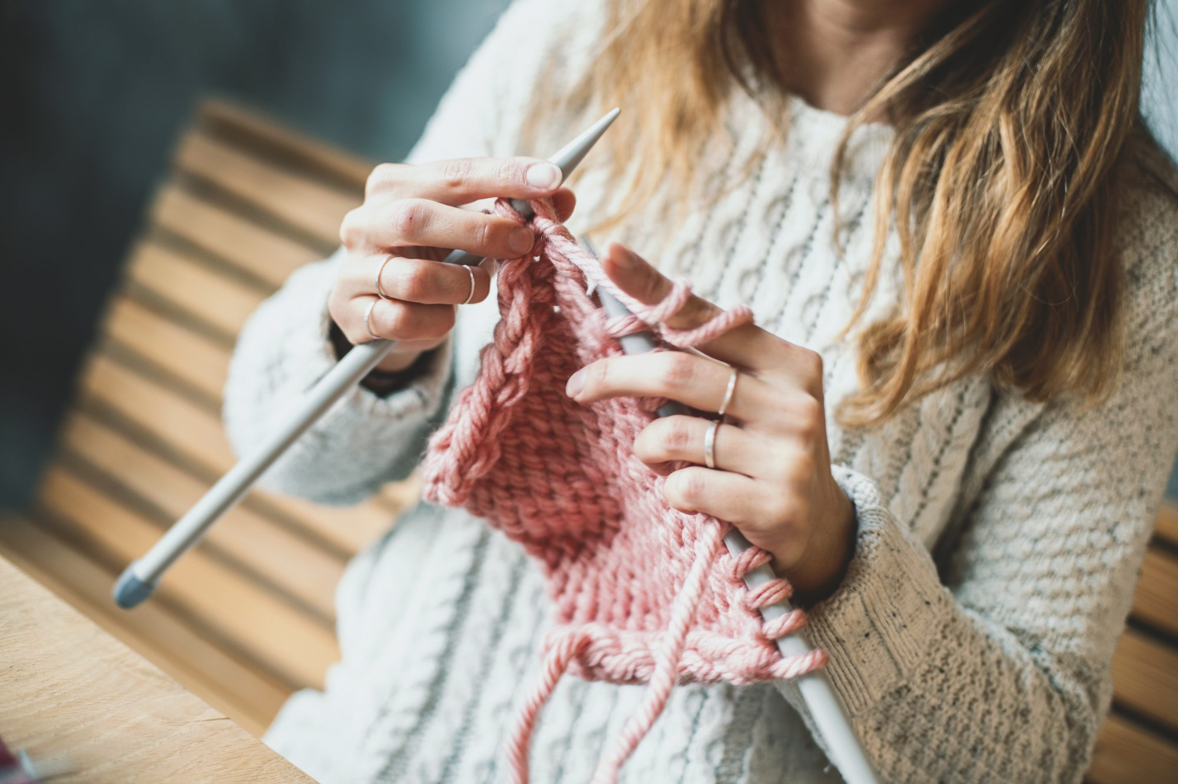

옛날에는 음식 만들기를 좋아했었어요. 그런데 요즘은 뜨게질이 재미있어서 매일 뜨게질을 해요.
1:
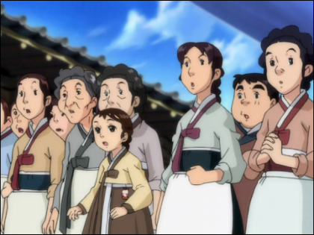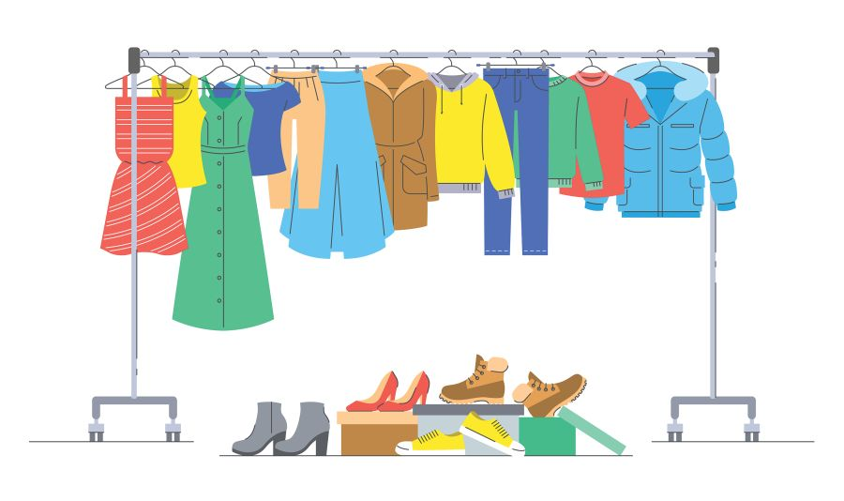

2:
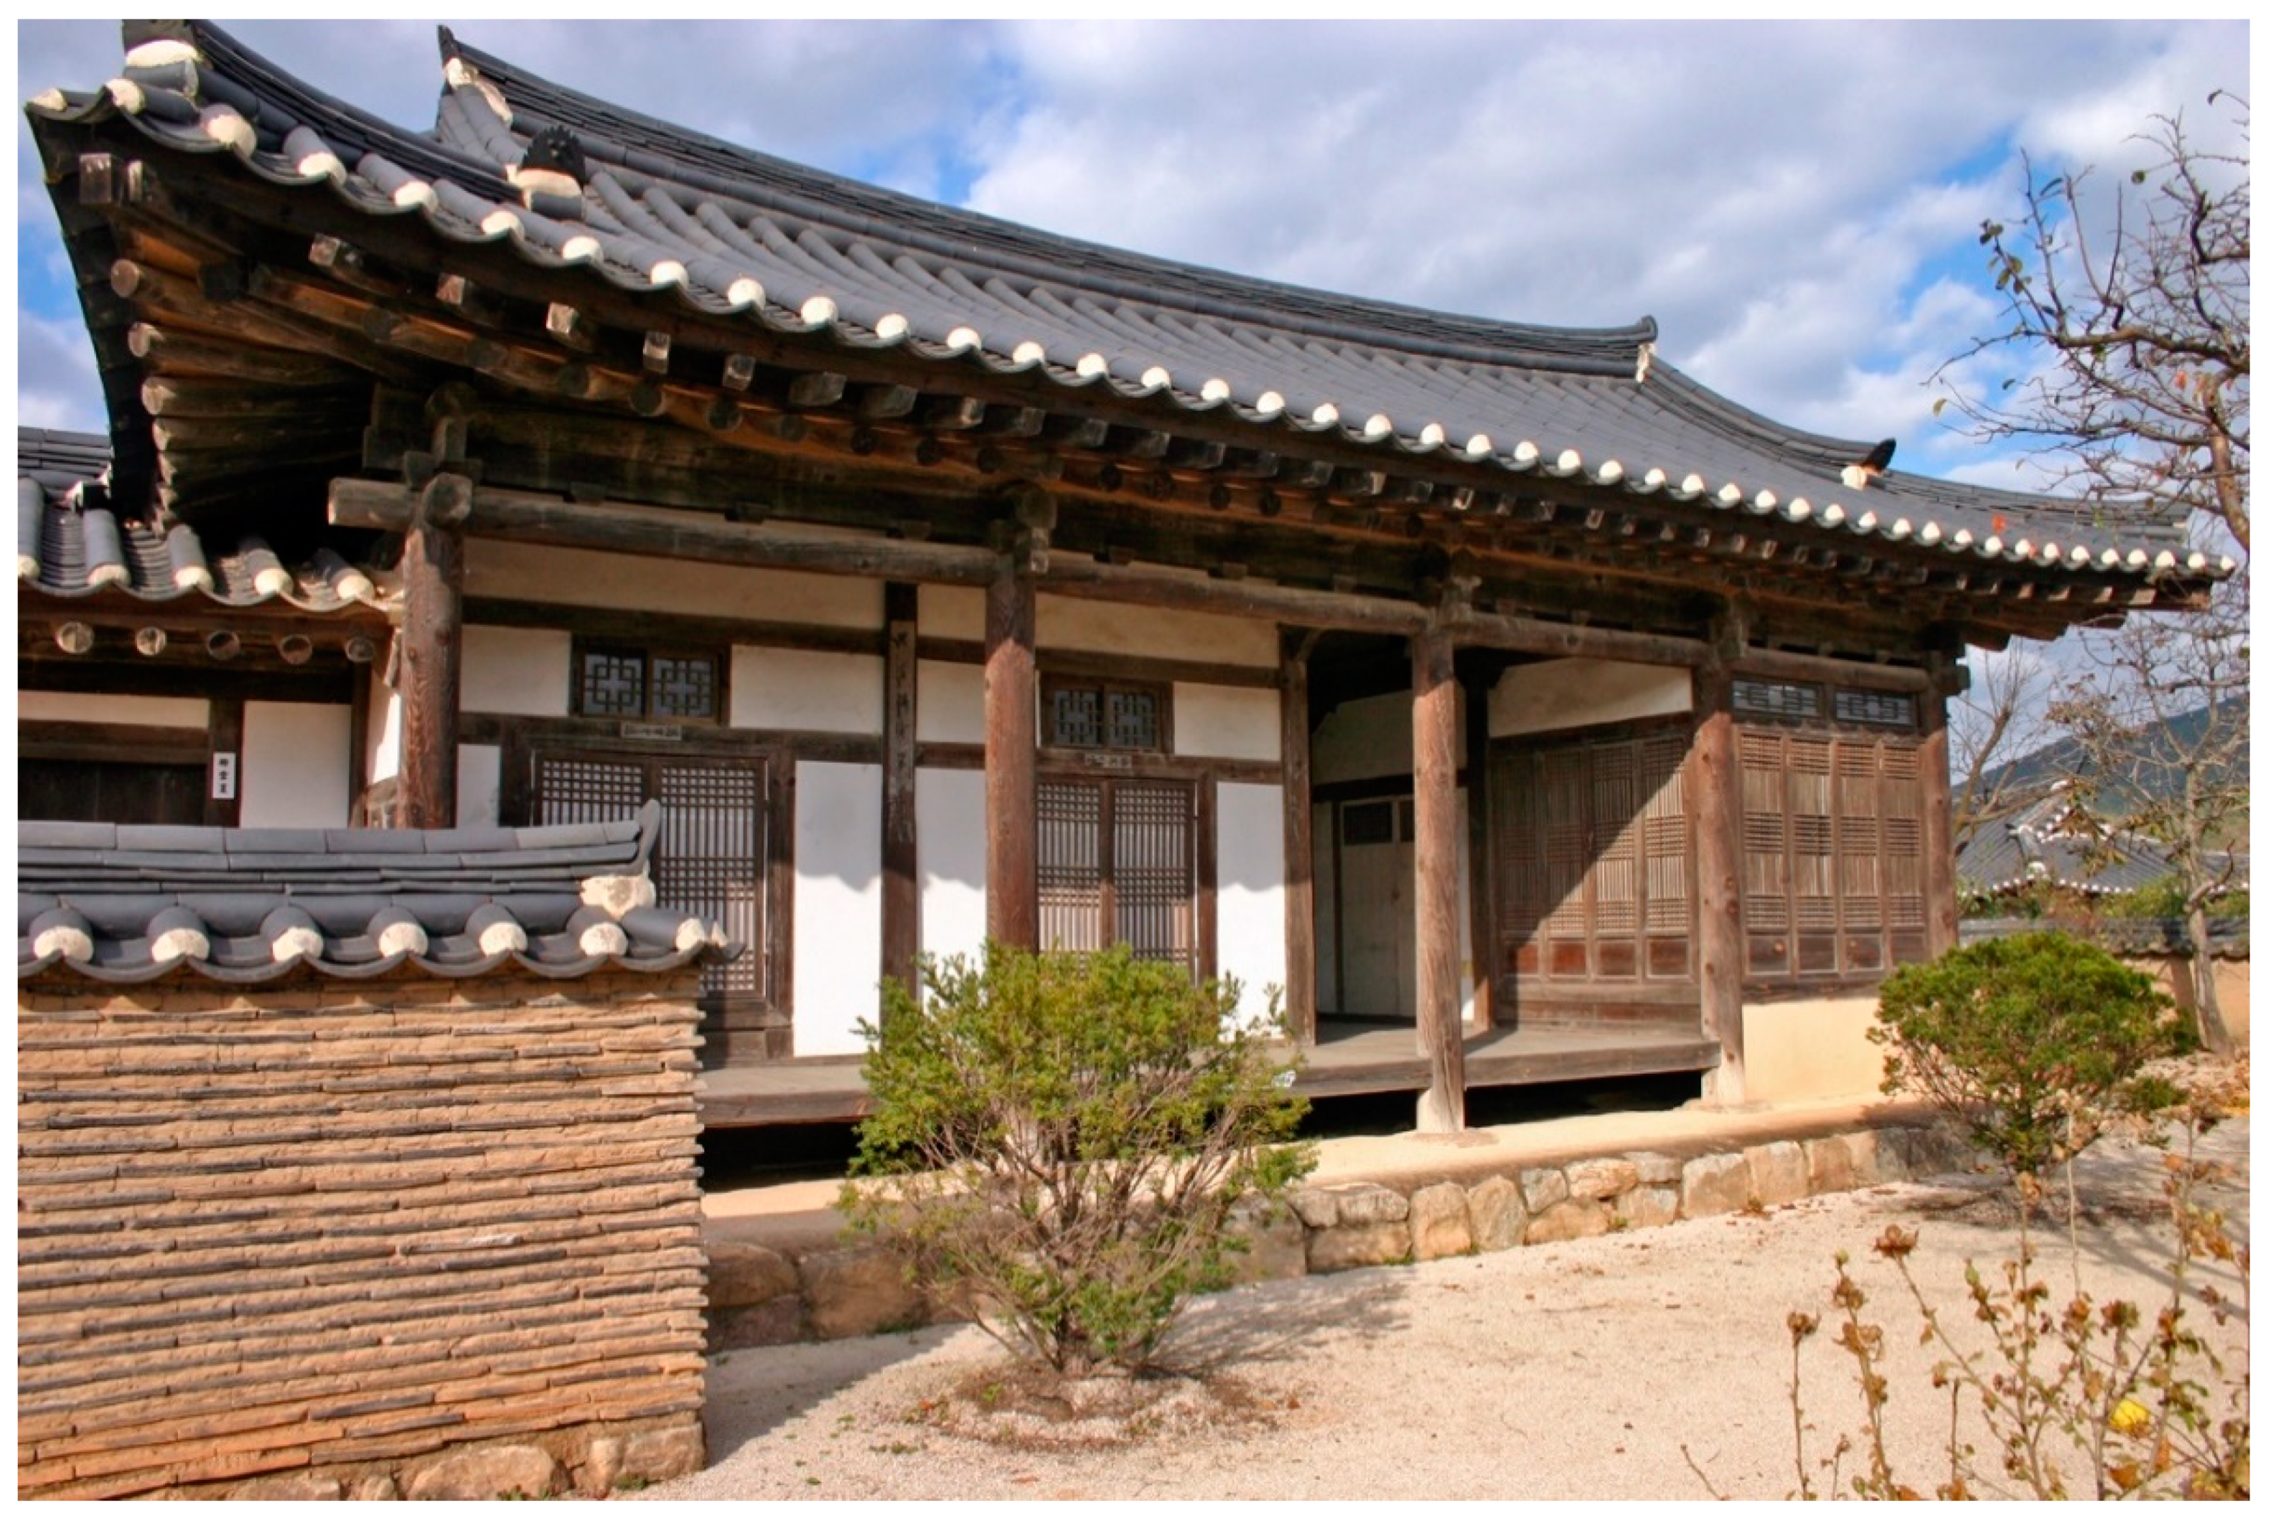
3:
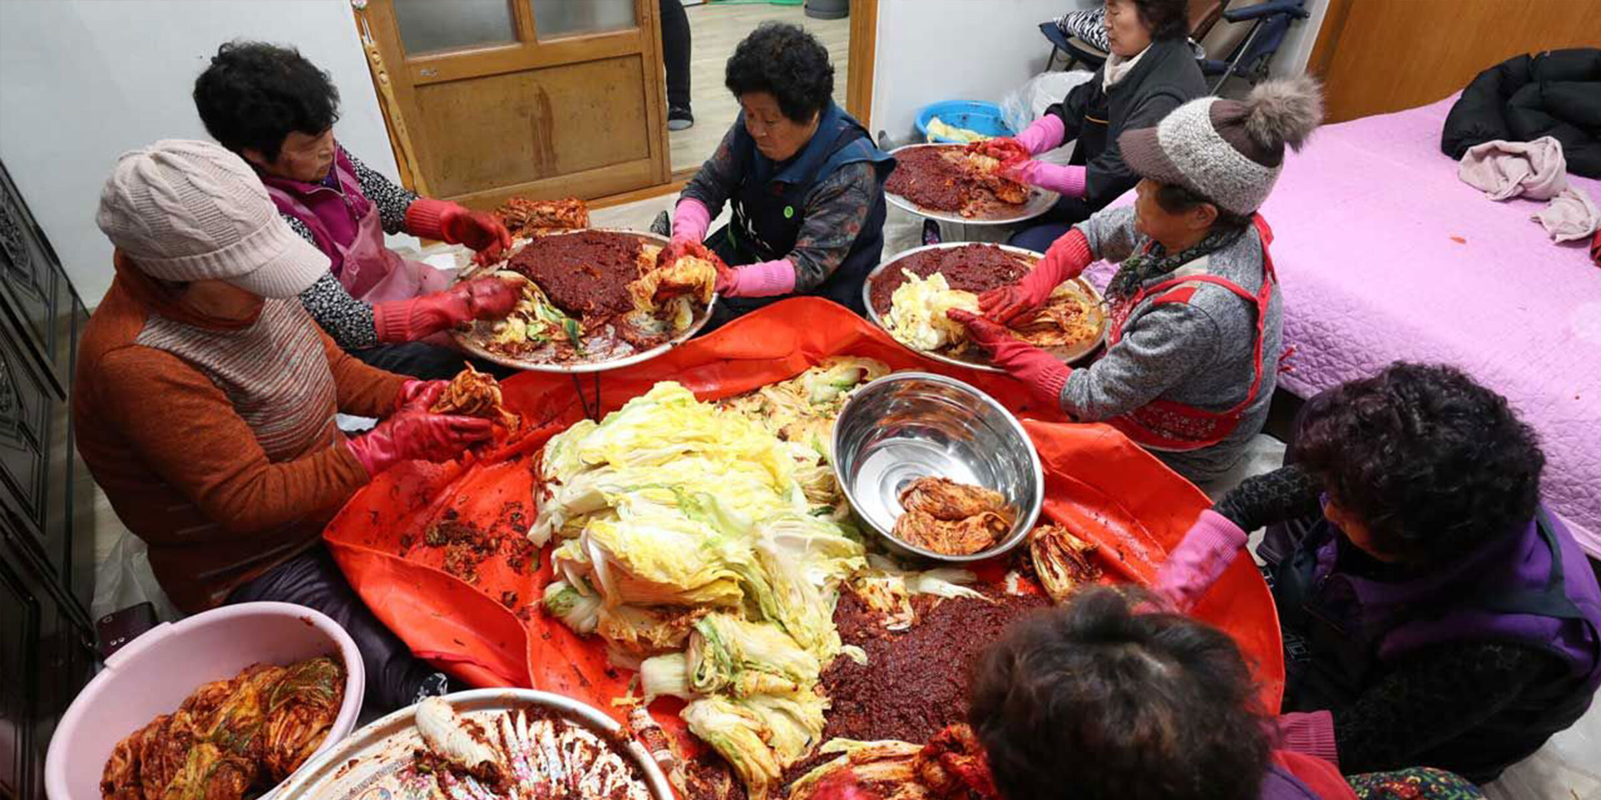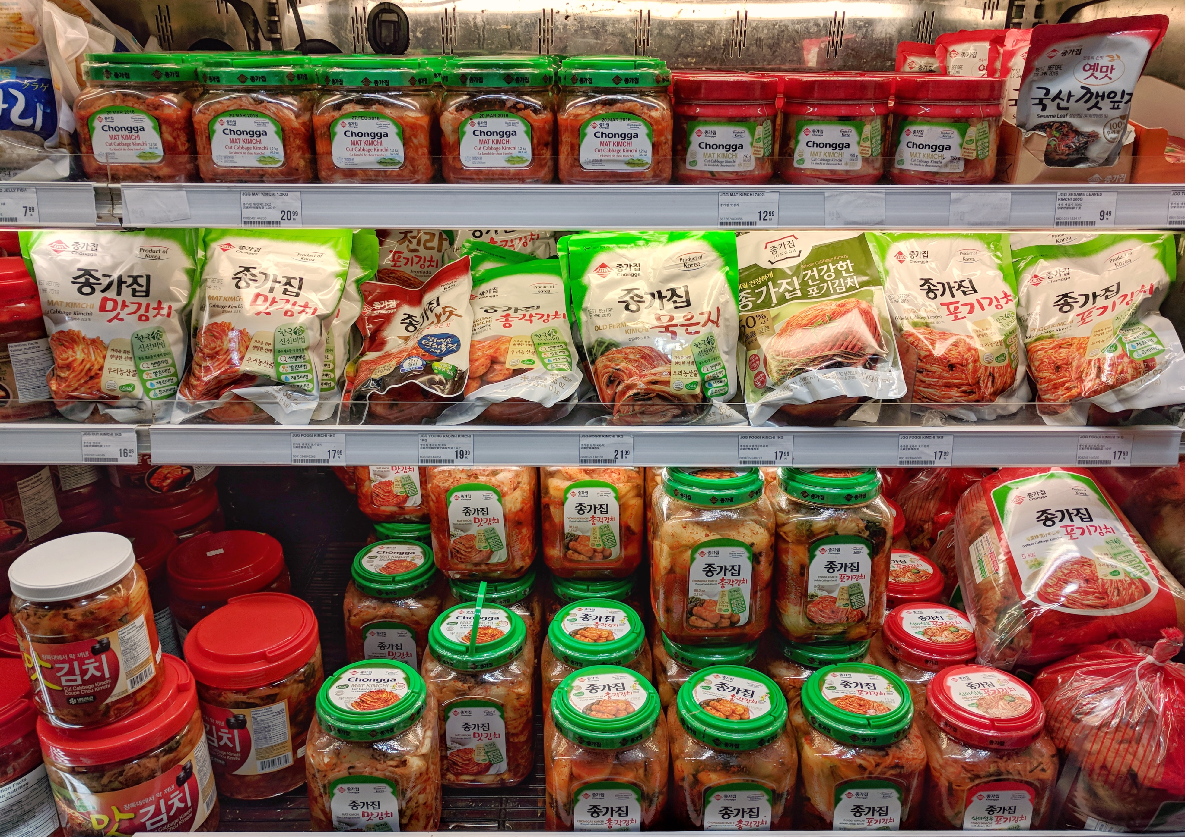

4:
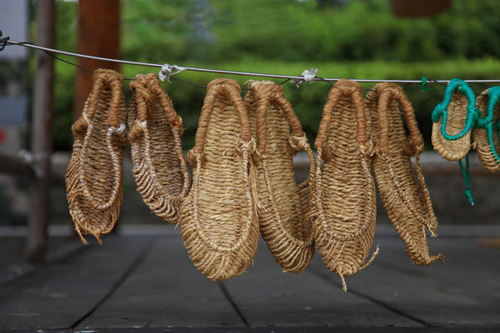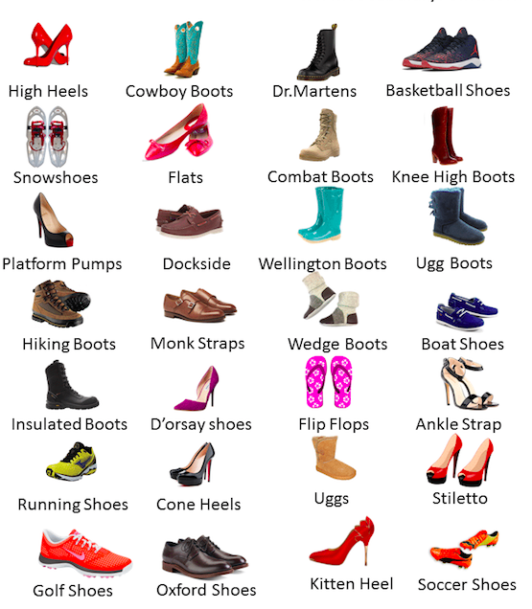

5:
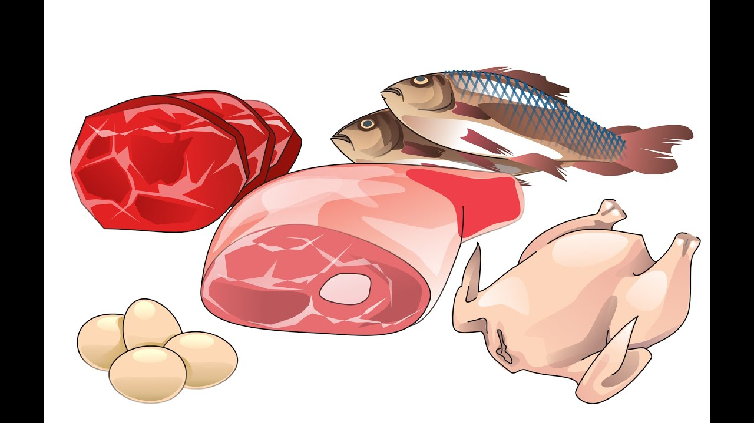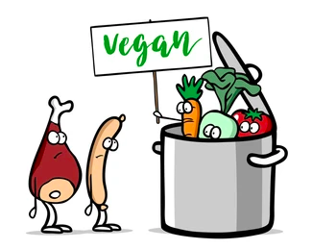

6:
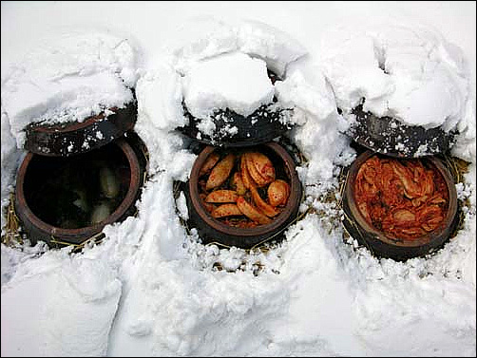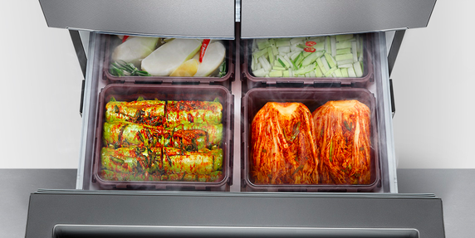
7:
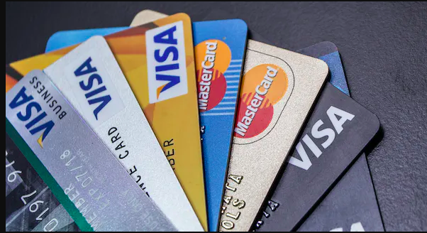

Section 4: Travel
Part A: You meet your friend on campus after a school vacation. Talk about where you have been and what you did with your friend. Translate and practice the following conversation with your partner in Korean.
A:
Speaker 1: Long time no see. Did you go to Korea during school vacation?
Speaker 2: Yes, I went and got back.
Speaker 1: How was it?
Speaker 2: It was good but so many things have changed.
Speaker 1: Oh no! Did you go to your favorite snack shop?
Speaker 2: No, the snack shop I used to go every day after school was gone. There is a coffee shop now.
Speaker 1: You must have been sad.
Speaker 2: Yeah.

Part B: You are planning a trip to Korea. You need to call a travel agent to buy a ticket. Use the space below to create the conversation. The conversation should be 30 seconds to 1.5 minutes for beginning levels and longer for upper levels. You will record this dialogue in the next section. Ask for help if necessary.
B:
Speaker 1:__________________________________________________________
Speaker 2: __________________________________________________________
Speaker 1: __________________________________________________________
Speaker 2: __________________________________________________________
Speaker 1: __________________________________________________________
Speaker 2: __________________________________________________________
Speaker 1: __________________________________________________________
Speaker 2: __________________________________________________________

Section 5: Record and Save Your Recording
Instructions: Perform the dialogue you created with your partner. Make sure you do not end your Zoom meeting until you have performed your dialogue with your partner.

