JLP07 Existence Verbs (Chapter 4)
STOP: Before you begin this activity, open and follow recording instructions here.

Pair # _________

Partner A: ________________________________
Student ID: _______________________________
Instructor: ________________________________
Level: ______________ Date: ________________
Partner B: ________________________________
Student ID: _______________________________
Instructor: ________________________________
Level: ______________ Date: ________________

All links in this activity direct to the JLP Activities page on the LLC website. Find your activity number and click the drop down to find links to videos, audio, and/or websites used in this activity.

Section 1: Vocabulary Mastery
Instructions: Write the translation of the following words and phrases into Japanese. Try to use your book and your partner before using other materials or the internet. In the third column, draw a picture, write a note to yourself or put some kind of pronunciation guide for Japanese. Use the third column to help remember the word in Japanese.
Vocabulary | Translation | Notes/Pictures/Pronunciation Guide (anything to help you)
- There is/ There are/ (non-living things)
- There is/ There are (living things)
- Park
- Tree
- Bird
- Cat
- Dog
- Cafe
- Restaurant
- Aquarium
- Zoo
- Shopping Mall
- Town or City
- Bed
- Desk
- Chair
- Cellphone
- Houseplant
- Computer
- A lot/ many

Concept Check: ある(aru) vs. いる(iru)
In English, we say “There is” or “There are” to describe both living and non-living things. However, in Japanese, we use the verb “いる” to describe living things such as people, plants, and animals and we use “ある” to describe everything else. These verbs are very useful and can be used in many different ways.
To use these verbs in a sentence, you can use this simple formula: Noun が あります/ います。You can also add Place に in front of the noun if you want to describe where something is.
Check out the table on the next page to see different ways to useある and いる.

Uses of ある and いる:
Verb | Example (Japanese) | Translation
ある (Affirmative) | としょかんにたくさんほんがあります。  (Toshokan ni takusan hon ga arimasu. ) | There are many books in the library.
ある (Negative) | わたしのへやにコンピューターがありません。  (Watashi no heya ni konpyuutaa ga arimasen. ) | I do not have a computer in my room.
いる (Affirmative) | つくえのうえにかんようしょくぶつがいます。  (Tsukue no ue ni kanyoushokubutsu ga imasu. ) | There is a houseplant on the desk.
いる (Negative) | きょう、こうえんにあまりとりがいません。  (Kyou, koen ni amari tori ga imasen.) | There are not many birds in the park today.

Section 2: In Taro’s Room
Instructions: Look at the picture below. Take turns with your partner describing the numbered objects using あります and います. Write your sentences on the next page.
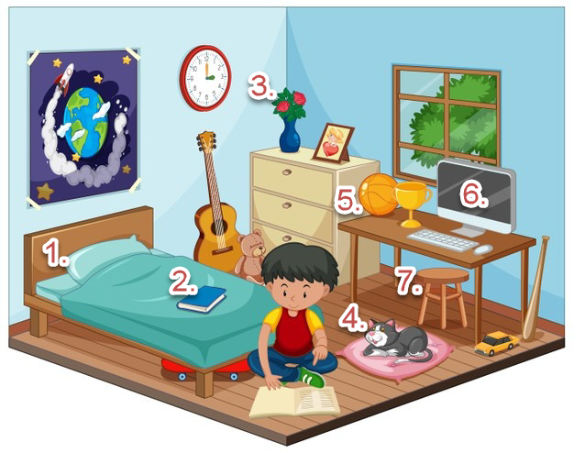
- _____________________________________________________________________________________
- _____________________________________________________________________________________
- _____________________________________________________________________________________
- _____________________________________________________________________________________
- _____________________________________________________________________________________
- _____________________________________________________________________________________
- _____________________________________________________________________________________

Section 3: Dialogue Creation
You are talking on the phone with your friend who lives abroad. Ask them about what there is in their town. Describe your town to them as well.
Instructions: Use the space below to help create the conversation. The conversation should be 30 seconds to 1.5 minutes. You will perform this dialogue in the next section. Ask for help if necessary.
Speaker1:
Speaker 2:
Speaker 1:
Speaker 2:
Speaker1:
Speaker 2:
Speaker1:
Speaker 2:
Speaker 1:
Speaker 2:

Section 4: Record and Save Your Recording
Instructions: Perform the dialogue you created with your partner. Make sure you do not end your Zoom meeting until you have performed your dialogue with your partner.

