JLP05: Daily Routine (Chapter 3)
STOP: Before you begin this activity, open and follow recording instructions here.

Pair # _________

Partner A: ________________________________
Student ID: _______________________________
Instructor: ________________________________
Level: ______________ Date: ________________
Partner B: ________________________________
Student ID: _______________________________
Instructor: ________________________________
Level: ______________ Date: ________________

All links in this activity direct to the JLP Activities page on the LLC website. Find your activity number and click the drop down to find links to videos, audio, and/or websites used in this activity.

Section 1: Vocabulary Mastery
Instructions: Write the translation of the following words and phrases into Japanese. Try to use your book and your partner before using other materials or the internet. In the third column, draw a picture, write a note to yourself or put some kind of pronunciation guide for Japanese. Use the third column to help remember the word in Japanese.
Vocabulary | Translation | Notes/Pictures/Pronunciation Guide (anything to help you)
- To go
- To brush (teeth)
- To listen; to hear
- To drink
- To put on (a hat)
- To read
- To get up
- To eat
- To sleep
- To drive
- To come
- To study
- Early
- To take a shower
- Car
- Hat
- Movie
- Music
- Home, house
- Weekend

Concept Check: ます(masu) form
In Japanese, leaving verbs in their dictionary form is very informal and usually only small children or people who are very close speak this way. Most adults use ます form when speaking to each other because it sounds more polite.
To conjugate a verb into ます form, you must first decide if it is an u-verb, ru-verb, or irregular verb. For most verbs, it is very easy to tell. If they end in an “う” sound, they are u-verbs and if they end in a “る” sound, they are ru-verbs. However, it is important to remember the irregular verbs する(suru) and くる(kuru) because they do not follow the same conjugation rules.

Guide for changing verbs from dictionary form to ますform:
Verb Type | Dictionary Form | Transformation Rule | ます Form
u-verb | いく(iku) | Change the final うsound to い sound in the same column and add ます | いきます(ikimasu)
ru-verb | たべる(taberu) | Drop る and add ます | たべます(tabemasu)
Irregular Verb | べんきょうする  (benkyousuru) | Only two verbs are irregular:くる and する  - くる きます  - する します | べんきょうします  (benkyoushimasu)

Section 2: Sentences with ます
Instructions: Fill in the blank with the ます form of the verb provided. Then, translate the sentences into English.
- まいにちはちじに ______________。 (おきる)
____________________________________________________________________________________________________
- おんがくを ______________。(きく)
____________________________________________________________________________________________________
- おちゃを ______________。 (のむ)
____________________________________________________________________________________________________
- うちでほんを ______________。(よむ)
____________________________________________________________________________________________________
- テレビを ______________。(みる)
____________________________________________________________________________________________________
- しゅうまつにスポーツを ______________。(する)
____________________________________________________________________________________________________

Section 3: Robert’s Morning Routine
Instructions: Watch the video of Robert’s morning routine and write 5 sentences describing what he did using ます form.
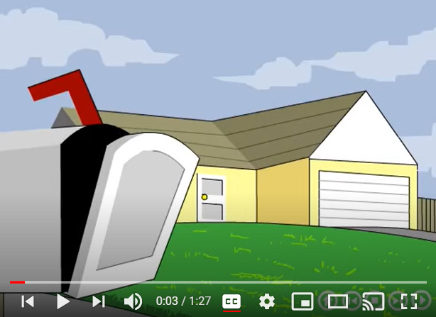

Section 4: Dialogue Creation
Ask your partner about their daily routine. Take turns sharing what kinds of activities you do every day.
Instructions: Use the space below to help create the conversation. The conversation should be 30 seconds to 1.5 minutes. You will perform this dialogue in the next section. Ask for help if necessary.
Speaker1:
Speaker 2:
Speaker 1:
Speaker 2:
Speaker1:
Speaker 2:
Speaker1:
Speaker 2:
Speaker 1:
Speaker 2:

Section 5: Record and Save Your Recording
Instructions: Perform the dialogue you created with your partner. Make sure you do not end your Zoom meeting until you have performed your dialogue with your partner.

