LP11. Seasons and Weather

Pair #
STOP: Before you begin this activity, open and follow recording instructions here.

Partner A:
Student ID:
Instructor:
Language:
Level: Date:
Partner B:
Student ID:
Instructor:
Language:
Level: Date:

Section 1: Vocabulary Mastery
Instructions: Write the translation of the following words and phrases into your target language. Try to use your book and your partner before using other materials or the internet. In the third column, draw a picture, write a note to yourself or put some kind of pronunciation guide for the target language. Use the third column to help remember your target language.
Vocabulary | Translation | Notes/Pictures/Pronunciation Guide (anything to help you)
- Spring, Summer
- Fall, Winter
- January, February, March
- April, May, June
- July, August, September
- October, November, December
- What’s the weather like today?
- The weather is good/bad.
- It’s sunny.
- It’s calm.
- It’s hot.
- It’s cloudy.
- It’s raining./It’s pouring.
- It’s windy.
- It’s snowing.

Section 2: Verbal Expressions
Instructions: Translate these questions about weather into your target language. Practice asking and answering in the target language.
What is the weather in Walnut, CA?
Which months are a part of summer in California?
When does it rain in Walnut?
In Southern California, December is
In Southern California, September is
In Southern California, April is

Section 3: Weather around the World
Instructions: Go to a weather app on your phone OR https://www.accuweather.com/en/world-weather. Click on each city to get more information. Write a couple words to describe the weather in the cities below. With your partner, practice asking and answering about today’s weather in these cities in the target language.

Example: Los Angeles
Write: hot, sunny
Speak: What’s the weather in Los Angeles today? It is hot in Los Angeles. It is sunny.

Paris, France:
Beijing, China:
Tokyo, Japan:
Sydney, Australia:
Mexico City, Mexico
Moscow, Russia
Mumbai, India:
Cairo, Egypt:
Madrid, Spain:
Buenos Aires, Argentina:

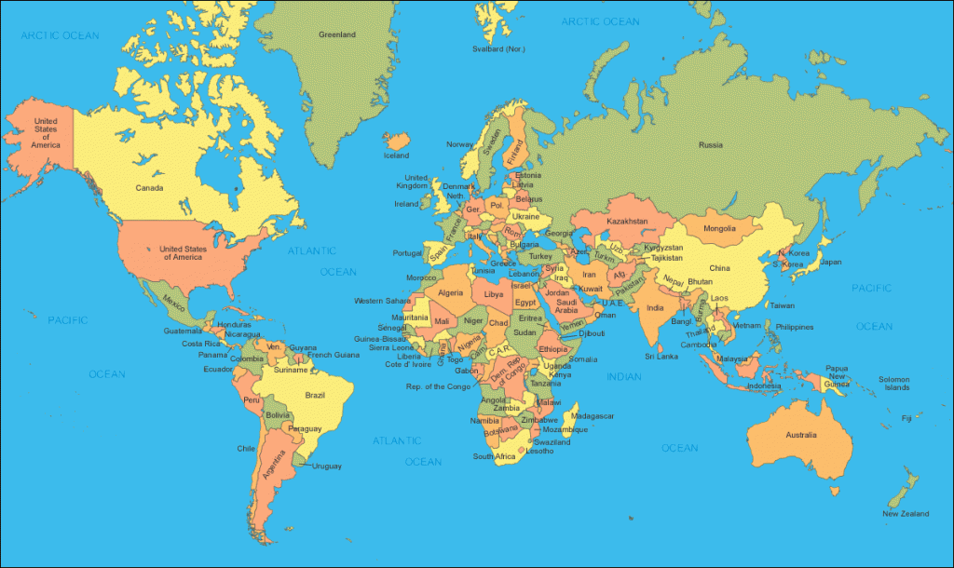

Section 4: Creating a Dialogue
Instructions: Ask your partner about the weather in their hometown or favorite city. Then switch roles and answer your partner’s questions about the weather in your hometown or favorite city. . Write your conversation here. Continue below if you need more space. You will perform this dialogue in the next section.
Speaker 1:
Speaker 2:
Speaker 1:
Speaker 2:
Speaker 1:
Speaker 2:
Speaker 1:
Speaker 2:

Section 5: Perform Your Dialogue
Instructions: Perform the dialogue you created with your partner. Make sure you do not end your Zoom meeting until you have performed your dialogue with your partner.

