LP7. Telling Time

Pair #
STOP: Before you begin this activity, open and follow recording instructions here.

Partner A:
Student ID:
Instructor:
Language:
Level: Date:
Partner B:
Student ID:
Instructor:
Language:
Level: Date:

Section 1: Vocabulary Mastery
Instructions: Write the translation of the following words and phrases into your target language. Try to use your book and your partner before using other materials or the internet. In the third column, draw a picture, write a note to yourself or put some kind of pronunciation guide for the target language. Use the third column to help remember your target language.
Time Vocabulary | Translation | Notes/Pictures/Pronunciation Guide (anything to help you)
- What time is it?
- It’s noon.
- It’s midnight.
- It’s one o’clock.
- It’s one fifteen.
- It’s one thirty.
- It’s one forty-five.
- It’s two o’clock.
- It’s two forty.
- It’s twenty to three.
- It’s a quarter to three.
- It’s five to three.
- It’s three fifty.
- At what time do you wake up?
- At what time do you go to sleep?

Section 2: TV Schedule
Instructions: It’s Tuesday night, your internet is down, and all you can watch is network television. Your partner will use the TV schedule to ask you in your target language when a certain show will be on. Each partner will ask about 3 shows. Answer their questions and switch roles.
Student A: At what time is iZombie?
Student B: It’s at 9pm.
Retrieved from Twocentstv.com on 5/5/17

Section 3: What time is it in…?
Instructions: Go to https://greenwichmeantime.com/timepiece/world-clock/world/ and enter the cities #1-6. Tell your partner the time in that city. Optional: You can also show your partner the countries you want to travel to and find the time there too.
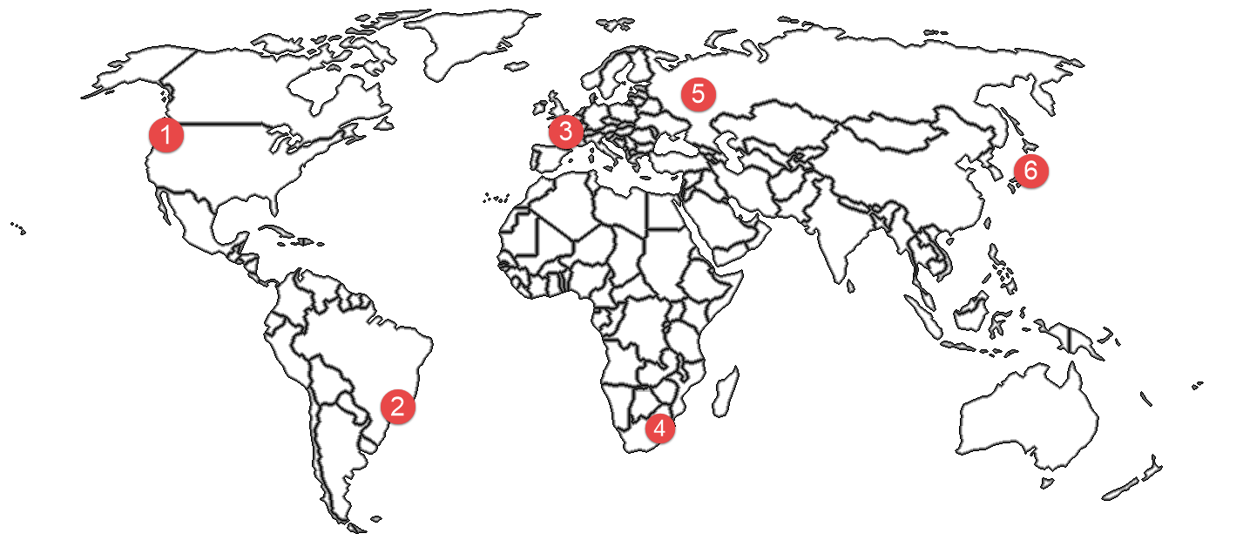

Example: It is four o’clock in Los Angeles.

- ________________________________________________
- ________________________________________________
- ________________________________________________
- ________________________________________________
- ________________________________________________
- ________________________________________________
Answers: 1. Seattle, 2. Rio de Janeiro, 3. Paris, 4. Johannesburg, 5. Moscow, 6. Tokyo

Section 4: Create a Dialogue
Instructions: What is your typical day at Mt. SAC? Ask your partner, for example, when they: leave their house, arrive on campus, eat breakfast, go to class, study, go to work, hang out with friends, etc. Switch roles and answer your partner’s questions. Write your conversation here. Continue below if you need more space. You will perform this dialogue in the next section.
Speaker 1:
Speaker 2:
Speaker 1:
Speaker 2:
Speaker 1:
Speaker 2:
Speaker 1:
Speaker 2:

Section 5: Perform Your Dialogue
Instructions: Perform the dialogue you created with your partner. Make sure you do not end your Zoom meeting until you have performed your dialogue with your partner.

