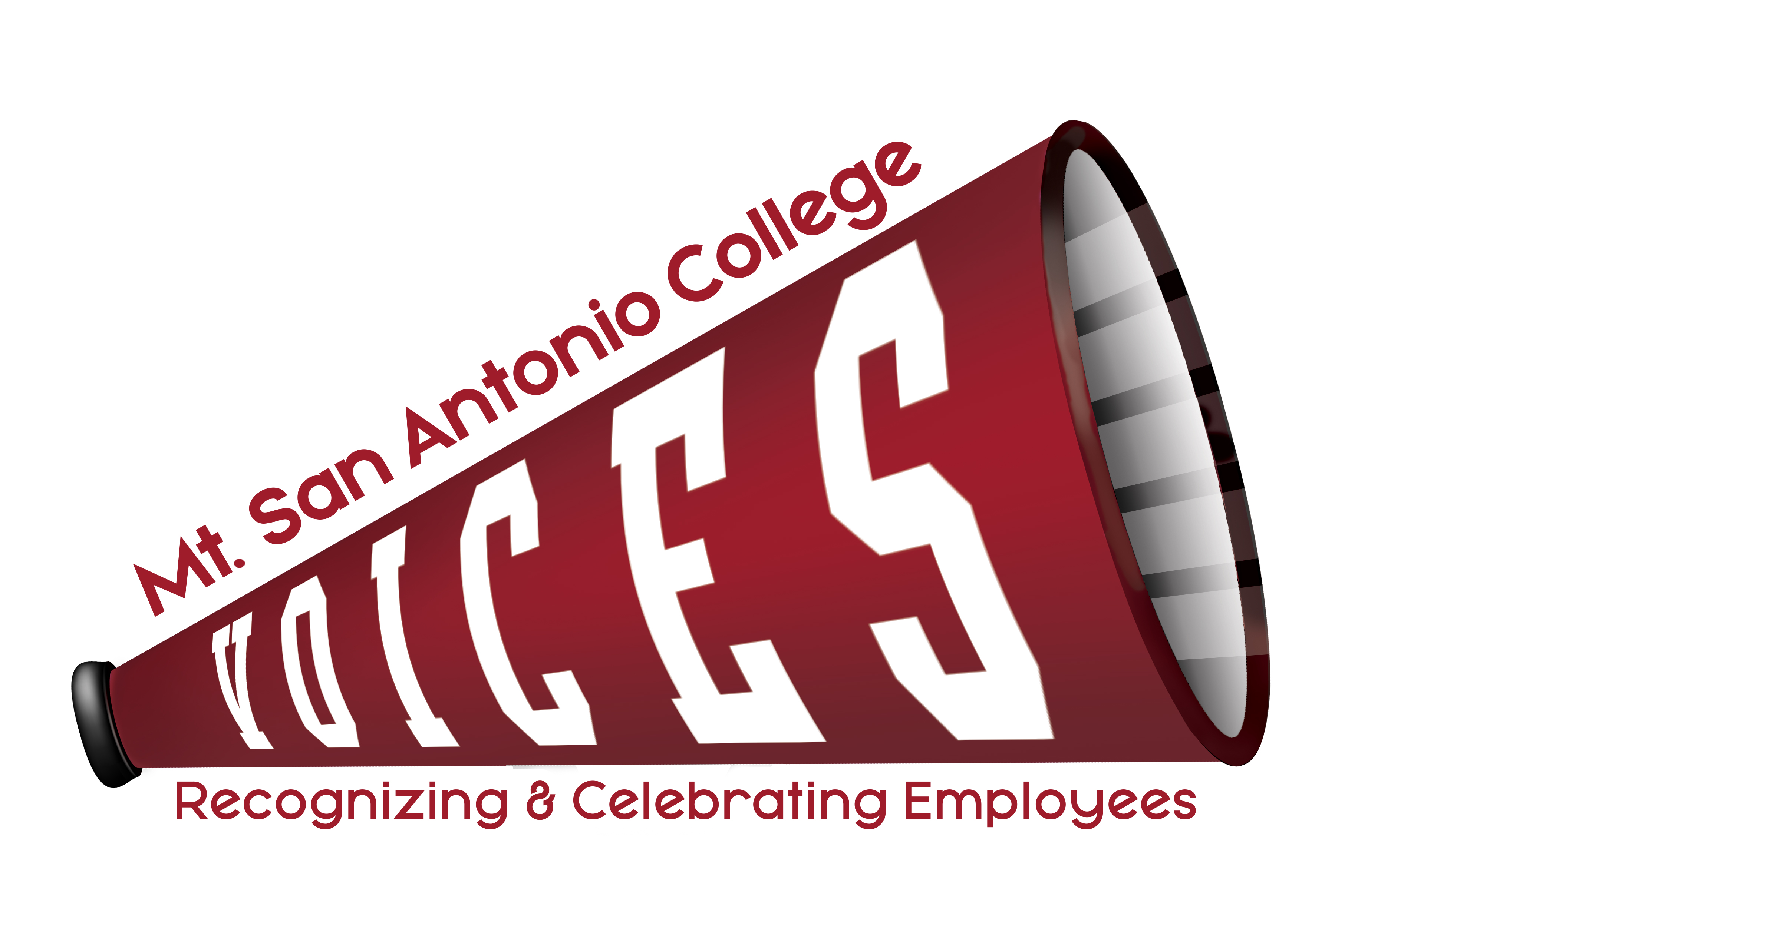
Minutes for July 17, 2018

12:30 to 1:30 p.m., 6-144

VOICES
 | Loralyn Isomura – Appointed by CSEA 262 |  | Ralph Jagodka – Appointed by Faculty Association
x | Eva Figueroa – Appointed by Classified Senate (Co-chair) | x | Ruben Flores – Appointed by CSEA 651
x | Lianne Greenlee – POD Director | x | Melissa Cone – Appointed by Confidentials
 | VACANT – Appointed by Academic Senate | x | Nicole Blean – Appointed by Management Steering
 | Julie Laverty – Member At-Large, Appointed by the President |  | Guest: Marlene Espina

ITEM | DISCUSSION | OUTCOME
Minutes | June 5, 2018 | Approved
Membership/Roles | Welcome new committee members!  - Ruben Flores  - Loralyn Isomura  Vacancy from Academic Senate. Martin Ramey is the contact. Maria Estrada is interested in joining VOICES.  Roles  - Need Secretary  - Need co-chair or sub-committees for committee projects | Eva will contact Martin Ramey for Academic Senate appointee.  Eva will prepare a list of what is involved for each role/project and include a timeline.
Celebration of Excellence | What went well?  - Music  - Having the Joe cutout at entrance  - 2 board members and the president attended  - One guest said that she felt honored to be celebrated  What can be improved?  - Next time track who attends/how many attend  - Logistics of guest list  - Clear expectations with Sodexo. They were not set up to start event on time; forgot dairy-free option.  - Earlier time for 651 employees; will depend on who wins awards next year  - Theme: Ice cream truck?  - No pre-printed tags because some people didn’t have one. Guests can just make their own. | The committee decided to schedule next year’s celebration on Friday, May 31, 2019. Eva will book Founders Conference Center now.
Way to Go, Joe | Facilities handed off the Joe to IT earlier this month. We should send the voting survey to IT as an option for selecting the next department.
College Champion Awards | We received 15 nominations (6 group nominations and 9 individual nominations).  We have 3 trophies left. Once again, we are struggling to get in touch with the Art department to have additional trophies made. Other options for future trophies include using an outside vendor or possibly 3D printing. | Eva will meet with Dr. Scroggins to give him the nominations received and discuss our issues with getting in-house trophies made.
Bulletin Board | Nicole is working on updating the VOICES bulletin board on the first floor of Bldg. 4.
Good of the Order | Not all members know how to access VOICES email. | Eva will send out instructions for how to access it.
Next Meeting | Tuesday, August 14, 2018 – 12:30-1:30 pm – POD, Innovation Room, 6-144

TOPICS FOR FUTURE MEETINGS
Website
Repository

