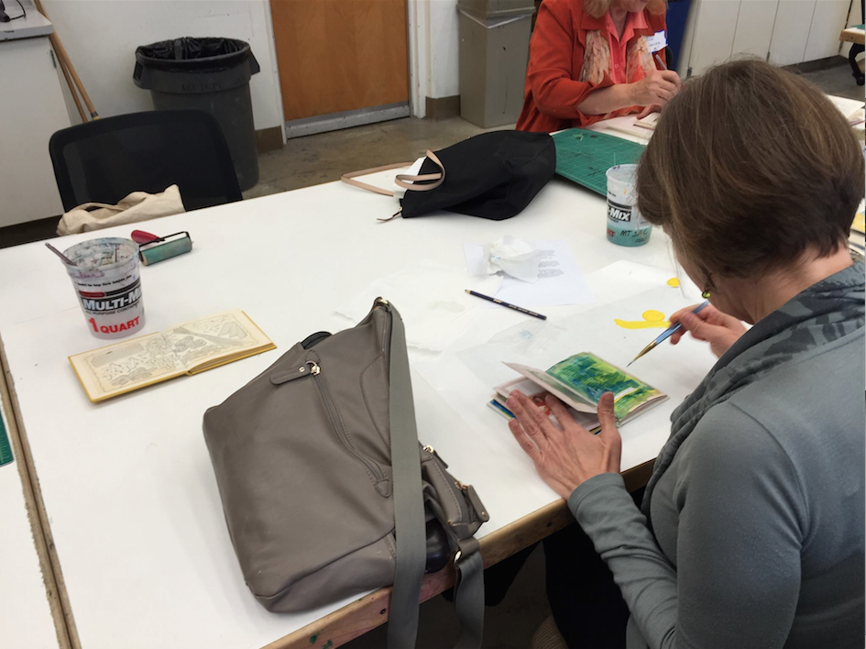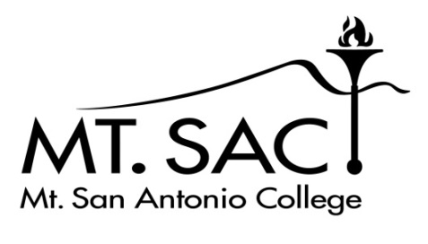

Mount San Antonio College is hosting its 2nd annual Weekend of the Arts featuring the 9th annual Writers’ Weekend. This event is open to participants from our college, other California colleges, and the surrounding community. Fiction, poetry, creative nonfiction writers, scriptwriters, actors, graphic artists, fine artists, and all creative minds: this is your chance to network, workshop, and create with others who share your passion.

**OUR MISSION STATEMENT**

We are committed to celebrating and cultivating the creative works of students and Mount San Antonio College and aspiring artists across the surrounding community.

**WHO IS INVITED**

Classes are available for all ages and experience levels, and we welcome everyone.

**REGISTRATION**

All participants must complete the Weekend of the Arts application by April 8, 2016. A $5 registration fee will cover expenses such as guest speaker and food.

**LUNCH**

Pizza will be provided Friday and Saturday. However, you will need to bring your own refreshments and snacks.

**WHAT TO BRING**

* Notebooks, sketchbooks, pens, and pencils
* Copies of your work to share
* Snacks and water

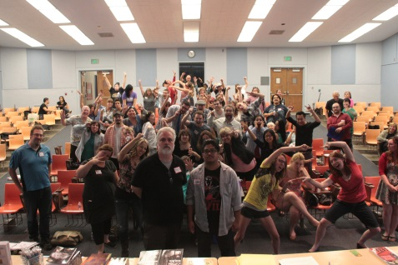

**WRITERS’ WORKSHOPS**

Generate new work with creative writing exercises and have your work critiqued by published writers, publishers, and fellow writers in a fun and comfortable environment. Get a unique look into professional writers’ creative process and share your knowledge and love of writing with others. Some of our workshop leaders this year will include: Myrenna Ogbu, YiShun Lai, Christopher Allan Poe, Bonnie Hearn Hill, Jo Scott-Coe, Christine Lynch, Chad Sweeney, and Stephanie Barbé Hammer.

**COLLEGE CREATIVE WRITING PROGRAMS**

Learn about the options and opportunities available for a degree in creative writing, including Master of Fine Arts (MFA) programs. Learn about these programs and the admission requirements. Start planning for your future in writing.

**PRESENTATION OF 2015-2016 WRITER’S DAY PRIZES**

Join us in congratulating our contest winners. This is an annual prize open to Mt. SAC students for fiction, creative non-fiction, poetry, and critical essays.

**OPEN MIC READINGS**

Open microphone readings are a great way to show appreciation for the work all writers do. Read your work, or you can just sit back and enjoy hearing others’ work.

**VISUAL ARTS WORKSHOPS**

Mt. SAC professors will lead workshops aimed at fusing the visual arts with other art forms, including writing and theater. Studio activities will explore elements of design, ceramics, printmaking, and drawing.

**VISUAL ART VISITING ARTIST SEMINARS**

Learn about the art field from art professionals in the industry through seminars and hands-on activities.

1100 N. Grand Ave. Walnut, CA 91789

April 22, 23, 24

Register Now! Classes are filling.

Featuring the 8th Annual Writer’s Weekend

2016

2nd Annual

Weekend

of the

Arts

Presents the