How to request funding from Associated Students

Follow these four (4) easy steps ...

Mt. San Antonio College, Student Life Office I Building 9C

STEP 1:VISIT THE A.S. WEBSITE
Go to http: 1/as.mtsac.edu under the "Forms & Documents" tab and download the
"Appropriation of Funding" form.

STEP 2: COMPLETE AN "APPROPRIATION OF FUNDING" FORM
Only College employees may complete and submit funding forms. Completed forms should be submitted to the AS. Secretary located in the Student Life Office (building 9C) at least six (6) weeks prior to the event date.

STEP 3: ATTEND SENATE AND EXECUTIVE BOARD MEETINGS
Follow-up with the AS. Secretary (ext. 4525) to find out when the student leaders will be voting on your request. Put the date on your calendar and make plans to attend BOTH the Senate and Executive Board meetings. The Senate approves or denies your request while the Executive Board ratifies or vetoes your request. It is recommended that you attend both meetings in order to answer any questions that the student leaders might have. Call the AS. Secretary (ext. 4525) on the following day to find out if the A.S. President approved or vetoed your request.

STEP 4: START PROCESSING REQUISITON(S) ON BANNER
Congratulations! If you made it to step four your request for funding was approved! Start the Banner requisition process immediately after your items have been approved. This means that you should touch base with whomever you listed as your Banner requisitioner and let him/her know to begin processing your requisition(s), POs, checks, reimbursements, Conference & Travel forms, or Independent Contractor payment(s). Everything requires four (4) approvals; so the sooner you get started the better! The Appropriation of Funding form must be completely filled out (requestor should complete all areas in blue type) and submitted to the AS. Secretary at least 6 WEEKS prior to the date of the event/activity to be considered for funding. Remember that AS. will NOT be doing any of this for you and that the responsibility falls on the requesting party.

IMPORTANT NOTICE
All purchases should be made via the Banner system. Advisors will NOT be reimbursed for purchases made outside of Banner unless it involves expenses related to travel and conference in which case the "Travel & Conference" form must be completed (call ext. 5515, Fiscal Services for questions regarding travel). CONFERENCES: Any conference funded by AS. is subject to having the A.S. President select the attendees.

Appropriation of Funding
Associated Students, Mt. San Antonio College

For Office Use Only

Request#: Date Received:

Organization: Type organization name here Person submitting form: Type name here Email address:
Phone: Type phone here

Sponsor: |  | Date:
Co-Sponsor: |  | Date:

Amount Requested: Type Here
Name of person that will process your Banner requisition( s): Type Here

Signature (of person listed above): Ext. Type Here

NOTE : The person listed MUST have completed Banner Requisition Training: otherwise you will NOT be able to access allocated funds . Also, this person is responsible for obtaining necessary approvals in Banner.
Name of Event:

Date of Event: Type Here Location : Type Here
(Note: You must complete a separate Use of Facilities Form to request campus facilities through Event Services)
Advisor Name: Type Here Extension: Type Here

Advisor Signature : Date:
If this is a conference request then provide the name and extension of the advisor attending.

Name: Type H ere Extension: Type Here

Signature Date: __________________________

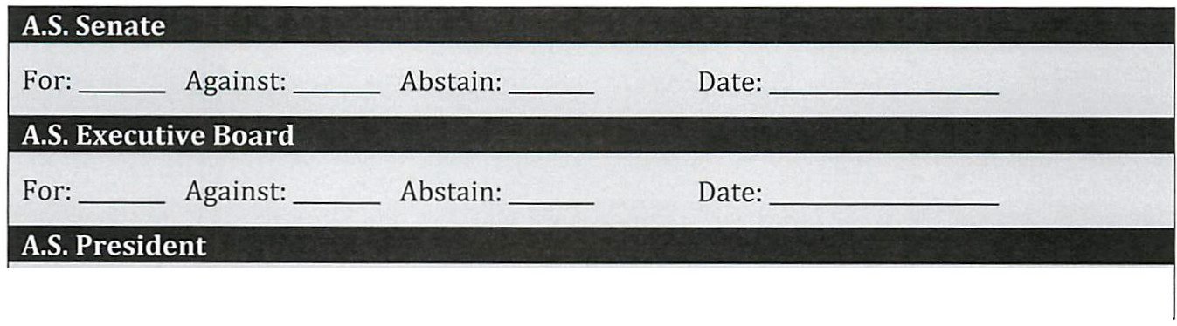Revised 09/08/14 Student Life Office Page 2

Please describe the purpose and nature of your event. Be sure to include how Mt. SAC students will benefit:

Tvpe detailed description h ere
Anticipated number of attendees: | Type Here
Students participating in this activity must have paid their current activity fee.
NOTE: Student Life no longer gives out "stickers" for the activity fee. Fees must be verified electronically, via the Associated Students website.
Who will be verifying this information?

Type Here
Cost breakdown: (Please be specific and include a separate line item for each expense).

Type detailed cost breakdown h ere

FUNDING CONDITIONS:

All groups requesting Associated Students funding are hereby notified that the event advisor (or designee) is responsible for processing all requisitions with approved vendors through the Banner system. Associated Students will NOT provide an expense envelope or petty cash for purchases. Although forms must be signed by the Director of Student Life, you (the requestor) are responsible for ensuring that all necessary forms and/or Banner requisitions are processed within the required timeframe.

This form must be completely filled out (requestor should complete all areas in blue type) and submitted to the A.S. Secretary at least 6 WEEKS prior to the date of the event/activity to be considered for funding. This will allow the Associated Students to review the nature of your request, approve the request, complete the process of allocating funds, and allow appropriate time for the event/activity to be advertised (in accordance with the A.S. Publicity Directive) . NOTE : If the event requires Board of Trustees approval (i.e. payment for speakers, performers, contracts, or out of state travel), clubs must submit the Board item to the Associated Students Secretary by the first of the month PRIOR to the month of travel or event. Other groups must submit board item(s) through their division.

Advisor:
Please initial to indicate that you have read and understood the A.S. "Funding Conditions"

INDEPENDENT CONTRACTOR(S):

If your event(s) requires that you pay speakers or performers for services, please complete the information below (A.S. does not make "donations" to groups). Any money paid for a service is considered to
Independent Contractor and must be approved by the Board of Trustees per Board Policy 6340 ("Contracts are not enforceable obligations until the Board of Trustees approves them"). Contracted Services, such as equipment rentals, also require a separate Board item. Please call the A.S. Secretary at ext. 4525 if you believe that you need a contracted service (other than catering).

If you have determined that you will be hiring an Independent Contractor, then please complete the information below for each person to be paid and e-mail the information to the A.S. Secretary (lhennings@mtsac.edu) at least 6 weeks pr ior to th e eyent d ate.
Approval of Independent Contractors : Must list name(s) of individuals

PROVIDER | Is this a College employee? | AREA/ DEPT. | SERVICE/ ASSIGNMENT | DATE(S) | AMOUNT | FUNDING SOURCE
Last name,  First name | Yes?  No? | Student Services/ Student Life/ Associ ated  Students | Type a description of the service here  (i.e. African Drummers  to perform at Culture  Fair) | Date(s) of event | Not to exceed  $XX | Associated Students
Last name,  First name |  | Student Services/ Student Life/ Associated Students | Type a short description of the service here  (i.e.African Drummers  Lo perform at Culture  Fair) | Date(s) of event | Not to exceed  $XX | Associated Students

