|  |
| --- |
| Session 1  Week 4 – Week 7  (March 18 – April 8) |
| Session 2  Week 9 – Week 12  (April 22 – May 13) |
|  |

Who? All non-native English speaking students in English, Speech, AMLA and intermediate/advanced ESL

Where? Building 66-205

When? Wednesdays, 2:30 – 4:00 (see session dates below)

### This is your opportunity to use English in a comfortable setting. Join us for:

### Food ◊ Drinks ◊ Games ◊ Fun

(AMLA students: Some professors accept completion certificates for portfolios or extra credit.)

#### Spring 2015

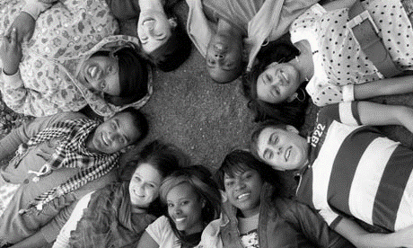

Back by popular demand!

Conversation Circles